ZORIA: AGE OF SHATTERING – FACT SHEET
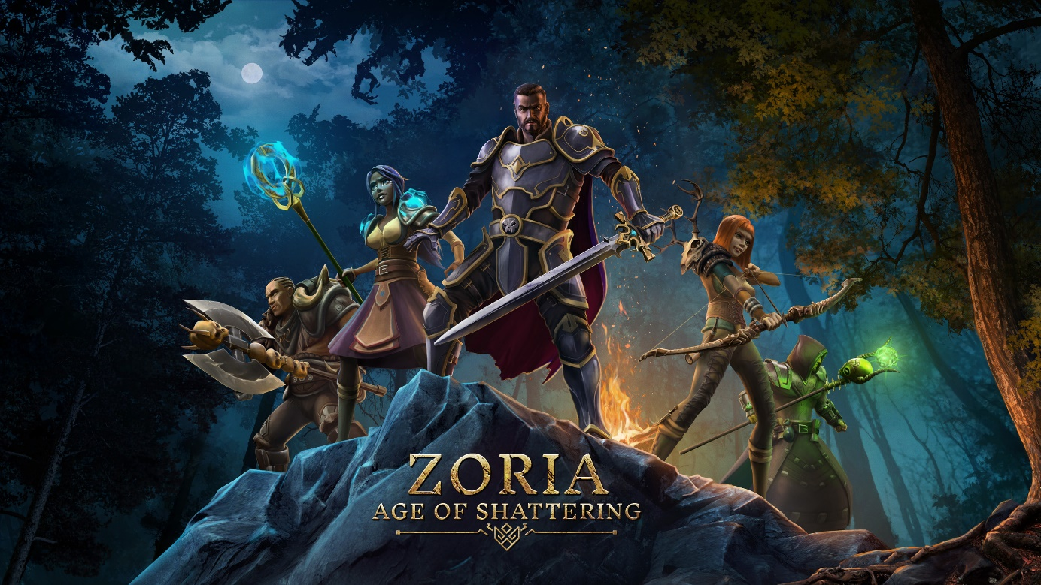

KEY FACTS
Title: Zoria: Age of Shattering
Developer / Publisher: Tiny Trinket / Anshar Publishing
Platforms: PC
Genre: Tactical RPG
Tags: CRPG, Strategy, Turn-based, Combat, Dungeon Crawler, Party-Based RPG, Lore-Rich, Tactical RPG, Single-Player, Open World
Setting: High-Fantasy
Release date: October 5th 2023
Price: TBD

Steam: https://store.steampowered.com/app/1159090/Zoria_Age_of_Shattering/
WWW: https://www.zoriagame.com
Facebook: https://www.facebook.com/ZoriaAgeOfShattering
Twitter: https://twitter.com/ZoriaGame
Discord: https://discord.gg/FEkvAJWw4a

ABOUT THE GAME
Zoria: Age of Shattering is a story-driven, party-based RPG with strong tactical elements, base and follower management that takes place in the expansive Fantasy world of Zoria, a world filled with magic, ancient history, tumultuous politics, and countless mysteries.

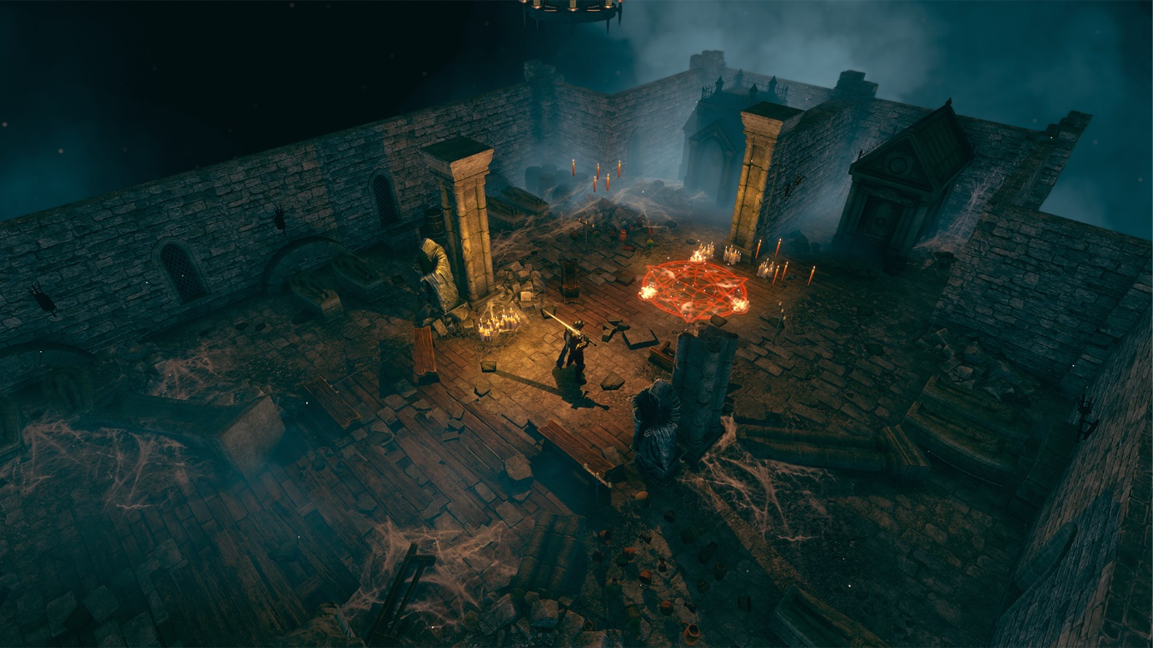

STORY
Zoria. Home. Mother of all her inhabitants. She provides her children with food to grow, shelter to rest in and also, the harsh lessons of life, so her offspring may learn to fight and protect her gifts to them. But men, men wanted more.
Zoria’s finest sons and daughters: intelligent, resourceful… violent. Men turned her ores into sword and daggers, and her roots into vile concoctions of poison.
Men wanted more. They craved more land and more food. So they built their homes of stone and wood, driving out the wildlife of its woods and caves. And in those caves they found their instrument of defiance: zerrium.

GAMEPLAY

Zoria’s Gameplay is a unique mix of action-adventure RPG and tactical management. Explore the beautiful lands of Zoria, from mountains to the ocean, towns and dungeons, follow the story or discover its secrets.
Your outpost is your base, by expanding it you get access to better facilities and the ability to influence more of the world around you while leveling your followers gives you the ability to explore deeper, further into the unknown.
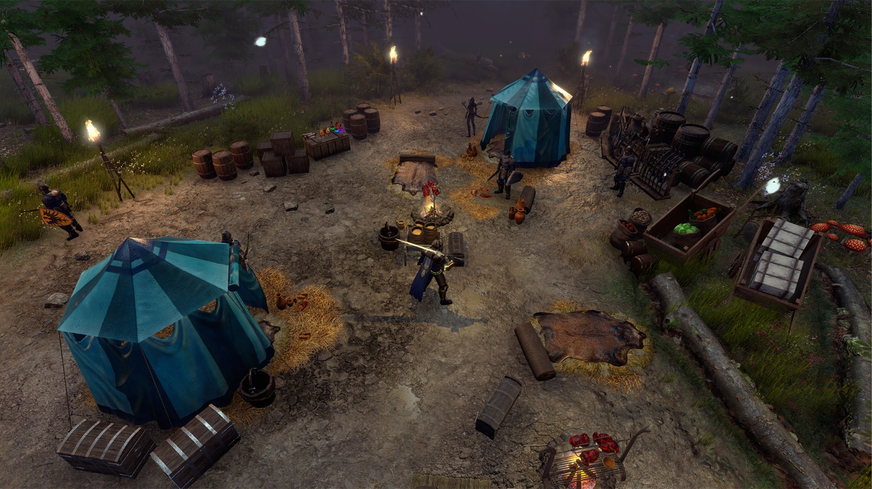

ADVENTURES

All the adventures in the game are hand-crafted, with multiple paths and various options for exploration, depending on the setup of your party and their environment abilities. You can always revisit a dungeon with another party to see previously inaccessible places and finish all the side quests.

RESOURCE MATERIALS

Adventures need to be planned out carefully, and supplies stocked accordingly. Without supplies, the team cannot restore their vital resources, making any dungeon that much more dangerous. Bringing enough supplies for the journey or upgrading your cooking skills to make better use of all the land has to offer, that’s a choice for everyone to make.

TURN-BASED COMBAT

Zoria’s combat is a Tactical, Turn-based confrontation, designed around the special characteristics of each class, abilities, resistances, deadly ranged attacks or strong AOE defenses, healing and much more. But turn based doesn’t mean static, so choose your battlegrounds wisely, as any wandering creature or enemy that gets too close, might join in and ruin your best laid plans.

ASSETS
All promo materials are available at this link: https://onedrive.live.com/?id=94E2DDAF00C8AD3A%218496&cid=94E2DDAF00C8AD3A

MEDIA CONTACT
Anshar Publishing
Paweł Janeda – PR Manager
E-mail: pawel.janeda@ansharpublishing.com
Mobile: +48 511 347 357
Twitter: @paweljaneda

General press inquiries related to other Anshar Publishing products: press@ansharpublishing.com

ABOUT TINY TRINKET
Three friends from Bucharest, Romania, who are in love with the RPG genre and believe together they can bring some freshness to the indie RPG market. We’ve been working on Zoria for seven years now; recently, we’ve been able to quit our jobs and in 100% committed to the project. We can see the destination point already, but there is still much work to do.

ABOUT ANSHAR PUBLISHING
Anshar Publishing focuses on providing comprehensive marketing and publishing services for PC and console games.
We believe that marketing deserves craftsmanship and an individual approach to each project, based on the expertise of our team professionals. Created in 2021, the team consists of Anshar Studios veterans and experienced specialists who gained their understanding of the industry at key Polish game studios. Apart from experience, we are a group of passionate gamers with an openness to support independent developers and increase the visibility of their hidden gems. We are ready to be challenged and pave the way to your target audience.
More info at: http://www.ansharpublishing.com

