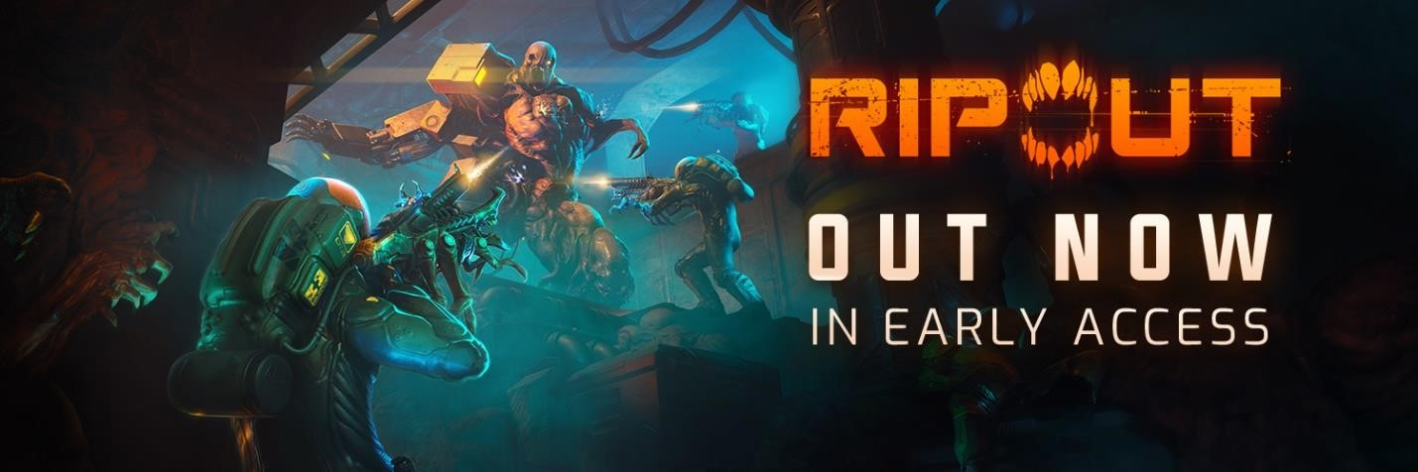

SCI-FI FPS RIPOUT Tears Into Early Access On Steam Today

Rip Apart Mutated Enemies With Your Trusty Pet Gun, and Save Humanity From Destruction just in time for Halloween.

AALBORG, Denmark -- Oct. 24, 2023 -- 3D Realms and Pet Project Games are thrilled to announce that RIPOUT, the co-op sci-fi horror FPS, is available today in Steam Early Access. Prepare to face the terrors of the future as you awaken from cryogenic slumber to find ships once occupied by humans have been taken over by mutated monsters. Face down mutant horrors alone or form a squad of up to 3 players and tear down monstrous enemies as you piece together what happened and search for Sanctuary, the last bastion of humanity.

RIPOUT’s early-access version includes the majority of features, variety of enemies and cooperative gameplay. During the early access period, the game will see several content updates that will include a variety of new features such as new enemies and weapons, new missions, and a lot more based on the feedback received by the community.

RIPOUT is available now in early access on Steam for $24.99, including a 10% launch discount. The game is also in development for consoles and will benefit from the community’s feedback in early access.

Launch Trailer: YouTube

Face off against mutant monstrosities transformed by Cell, a human made biological weapon
that has turned its sites on its creators, able to adapt their bodies in grotesque ways. Use your trusty biomechanical Pet Gun to gain a tactical advantage over your enemies by ripping weaponry off them while exploring procedurally generated derelict spaceships, collecting loot, and customizing your character to survive whatever dangers lurk around the corner.
Features:
- Cooperative PVE Gameplay: Embark on a variety of missions and explore derelict ships alone or in small teams. Be ready to rip apart a massive variety of genetically altered monsters, capable of strengthening and reconfiguring their bodies by attaching smaller mutants to them.
- Living Pet Gun: Don’t hold back as you use your trusty Pet Gun and harness the power of the sentient biotech for yourself and turn it against your foes.
- Weapon Modifications and Character Classes: Customize your weapon and choose between multiple character specializations to find the perfect mix for your playstyle.
- Endless Action: Explore countless derelict ships in quick, action-packed missions which will leave you guessing what horrors lurk around the corners. Thanks to RIPOUT’s procedurally generated level design, you’ll enjoy endless replayability.
- Scalable Difficulty: Expect a challenge for teams of all sizes, thanks to RIPOUT's scaling difficulty.

For more information about RIPOUT, visit the official RIPOUT website, follow them on X or join the Official Discord Community.

About 3D Realms
Redefining AAA - Action, Attitude, Adrenaline, 3D Realms has rocked the world for almost 30 years by publishing unforgettable, iconic games like Duke Nukem, Terminal Velocity, Shadow Warrior, Death Rally, Max Payne, and more recently Ghostrunner, Ion Fury, Cultic, Tempest Rising, Phantom Fury, RIPOUT.

Lead by industry veterans, 3D Realms is a proud member of the Embracer Group as part of Saber Interactive, with a mission of publishing games for grownups. Unapologetic and uncompromising... we’re not afraid of being who we are and being damn good at it - for everyone's benefit. For more information visit 3drealms.com.

About Pet Project Games
Pet Project Games is an indie video game company founded in January 2020. It consists of seasoned developers that have many years of experience in the gaming industry, developing multiple projects together. While working on these projects, they realized they could take the gaming experience to the next level and offer a new game. As passionate gamers and fans of classic video games, they are developing RIPOUT, their most ambitious project to date.

