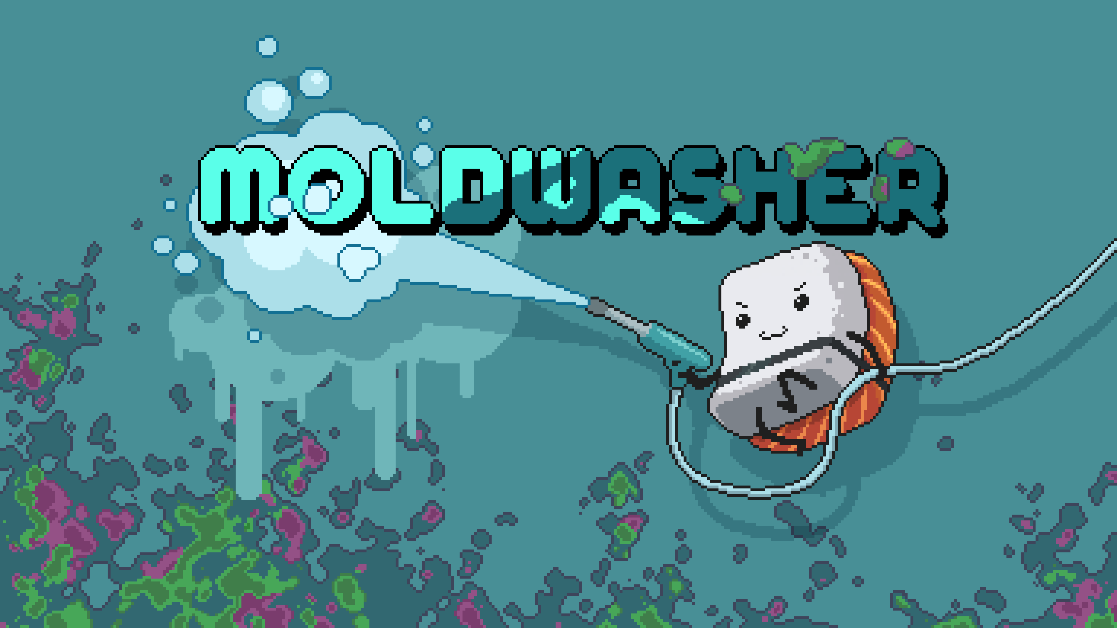
Document updated on: 17 September, 2025
Clean moldy messes as a brave food hero! Equip your high-pressure spray, choose the right nozzle, and clear away sticky messes in this cozy, arcade-style fridge-cleaning adventure.

Game Overview
- Genre: Relaxing, Casual, Cozy, Job Simulator, Pixel
- Platforms: PC (Steam)
- Release Date: 2026
- Developer: Rubel Games
- Publisher: Anshar Publishing

Key Features
Step into a whimsical world where mold has crept into every corner of your kitchen, shelves, and freezer — and it’s up to you to wash it all away! Armed with a trusty high-pressure sprayer, you’ll scrub, blast, and sweep your way through messy environments filled with sticky surprises and mischievous mold creatures.
Moldwasher combines the charm and lighthearted fun of job simulator–style games with the satisfying, organizing pull of titles like Unpacking and PowerWash Simulator.

This isn’t just cleaning — it’s a meditative arcade adventure where cozy vibes meet addictive gameplay.



Pressure-Powered Gameplay
Master your sprayer with precision! Swap between different nozzle modes to blast mold, wash away grime, or gently sweep back persistent pests. Experiment with water pressure and spray angles for maximum efficiency, then admire the spotless results.

Varied & Surprising Locations
From cluttered kitchen counters to overstuffed pantries, from forgotten freezer drawers to mysterious sewers — every level offers fresh challenges and hidden secrets. Peek behind jars, clear piles of old treasures, or even venture into spooky mold lairs. Each area feels alive with personality (and mess).

Strange & Sticky Foes
Face off against molds that are more than just fungus. Encounter shimmering crystalline colonies, ghostly spores, sticky iridescent blobs, and even sneaky mimics that disguise themselves as food! Each type has unique quirks, so no two encounters feel the same.

Adorable Food Heroes
You’re not a warrior in armor — you’re a healthy meal on a noble mission! Play as charming characters like a determined apple, a wise loaf of bread, or a cheerful veggie bowl, all fighting to stay fresh and protect the kitchen. Unlock more quirky heroes as you progress.

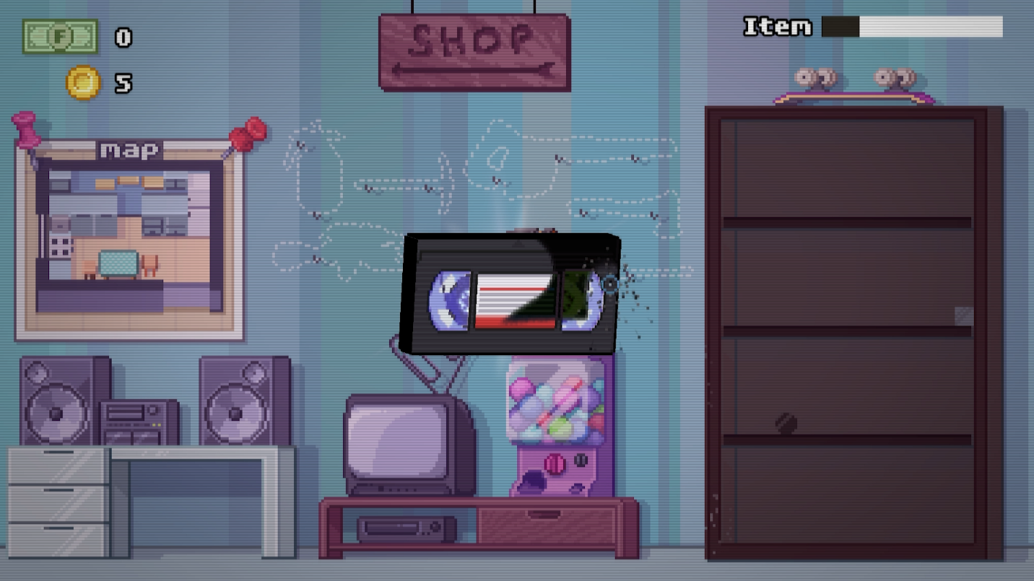

Progression & Unlocks
Earn points and rewards as you clean, then spend them on new sprayers, shiny upgrades, and cosmetic items to personalize your cozy basement hub. Unlock fresh food heroes, relaxing music tracks, and stylish gear — because even the cleanest heroes deserve flair.

Relaxing Yet Addictive
Sink into the soothing soundtrack and ASMR-like cleaning effects. The hiss of water, the sparkle of a clean surface, the gentle hum of background music — it all blends into a meditative experience that’s both calming and hard to put down.

Development and Roadmap
Team Size: 1 full-time developer with extensive experience and delivered games at itch.io and Steam.

Contact
- Press Pack: LINK
- Gameplay Trailer: LINK
- Steam Page: LINK
- Social Media: LINK
General Inquiries: press@ansharpublishing.com
Media Inquiries: malgorzata.chalas@ansharpublishing.com

