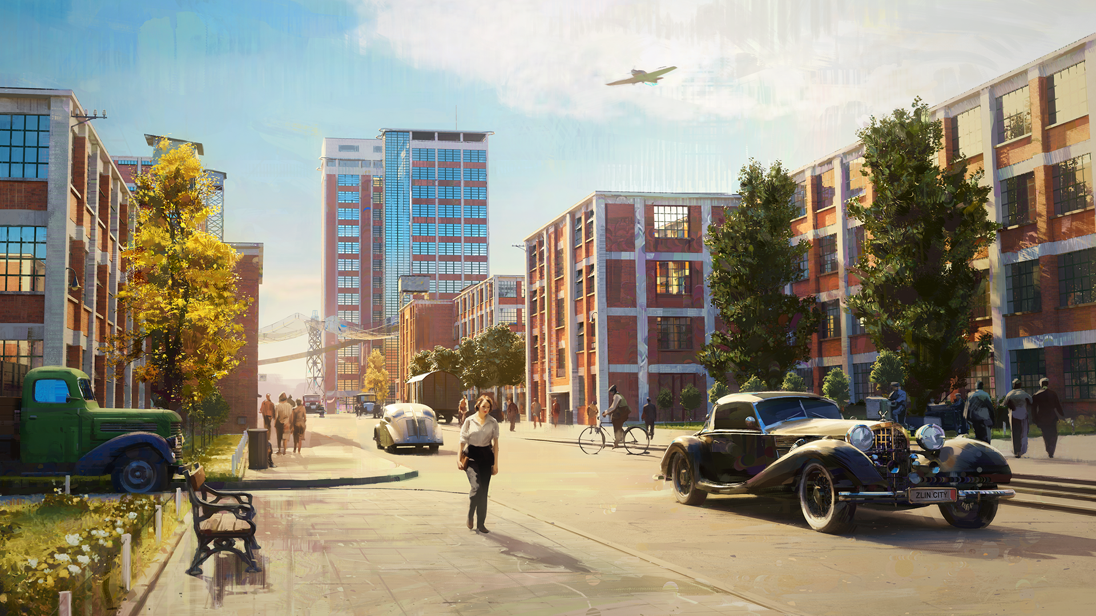

Zlin City

About
Build charming miniature diorama cities and train routes in a magical world inspired by the 1930s–40s. Create cozy towns, craft detailed rail networks, and relax to an original soundtrack. Inspired by real historical events and the architecture of Zlin.
Zlín City: Arch Moderna is a cozy, historically inspired city-building game that combines the charm of real miniatures, photogrammetry, and Unreal Engine 5. Players build small diorama cities set in the magical 1930–1940 period, guided by quests and requests from citizens, creating a relaxing and playful experience while exploring historical events.
The project’s most distinctive feature is its stunning visual style, which combines real miniatures, photogrammetry, and the capabilities of Unreal Engine. The game is also inspired by unique functionalist architecture and the magical 1930s-1940s period.
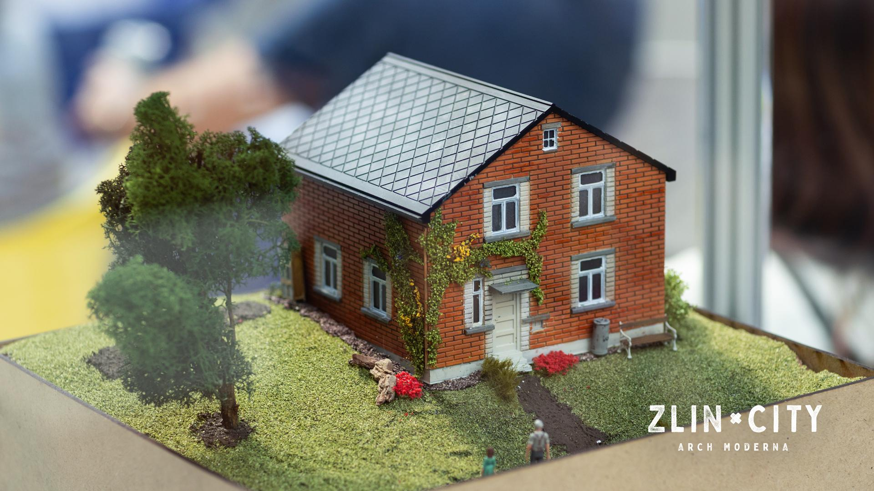
Equally exceptional is the gameplay: you build small diorama cities guided by ideas, requests, and quests from people, creating a relaxing, playful experience of growing and interacting with your own miniature world with original period soundtrack.

SUMMARY
Platform: PC (Possible consoles & mobile planned post-launch)
Game Mode: Single-player
Tags: Strategy, City-Building, Cozy, Relaxing, Casual Stylized,
Atmospheric, Indie, Educational, Historical, Sandbox
Engine: Unreal Engine 5
Similar Games: Tiny Glade, SimCity, The Sims, Tropico
Target Audience: Casual gamers of all genders, ages 6–60
Business Model: Premium base game + DLCs, merchandise, and soundtrack
Estimated Gameplay Time: 20+ hours

HANDMADE
At a time when most graphics are generated, Zlin City is beautifully imperfect and distinctively human. The beauty of miniatures and train models, kids' toys, or puppet animations, we all know.



UNREAL GRAPHICS
The only way to create such a game is with the latest digital technologies: Unreal Engine 5, 3D printing, and scanning. Its author, Pavel, waited several years before it was possible. It's about combining the old and the new to create something unique.

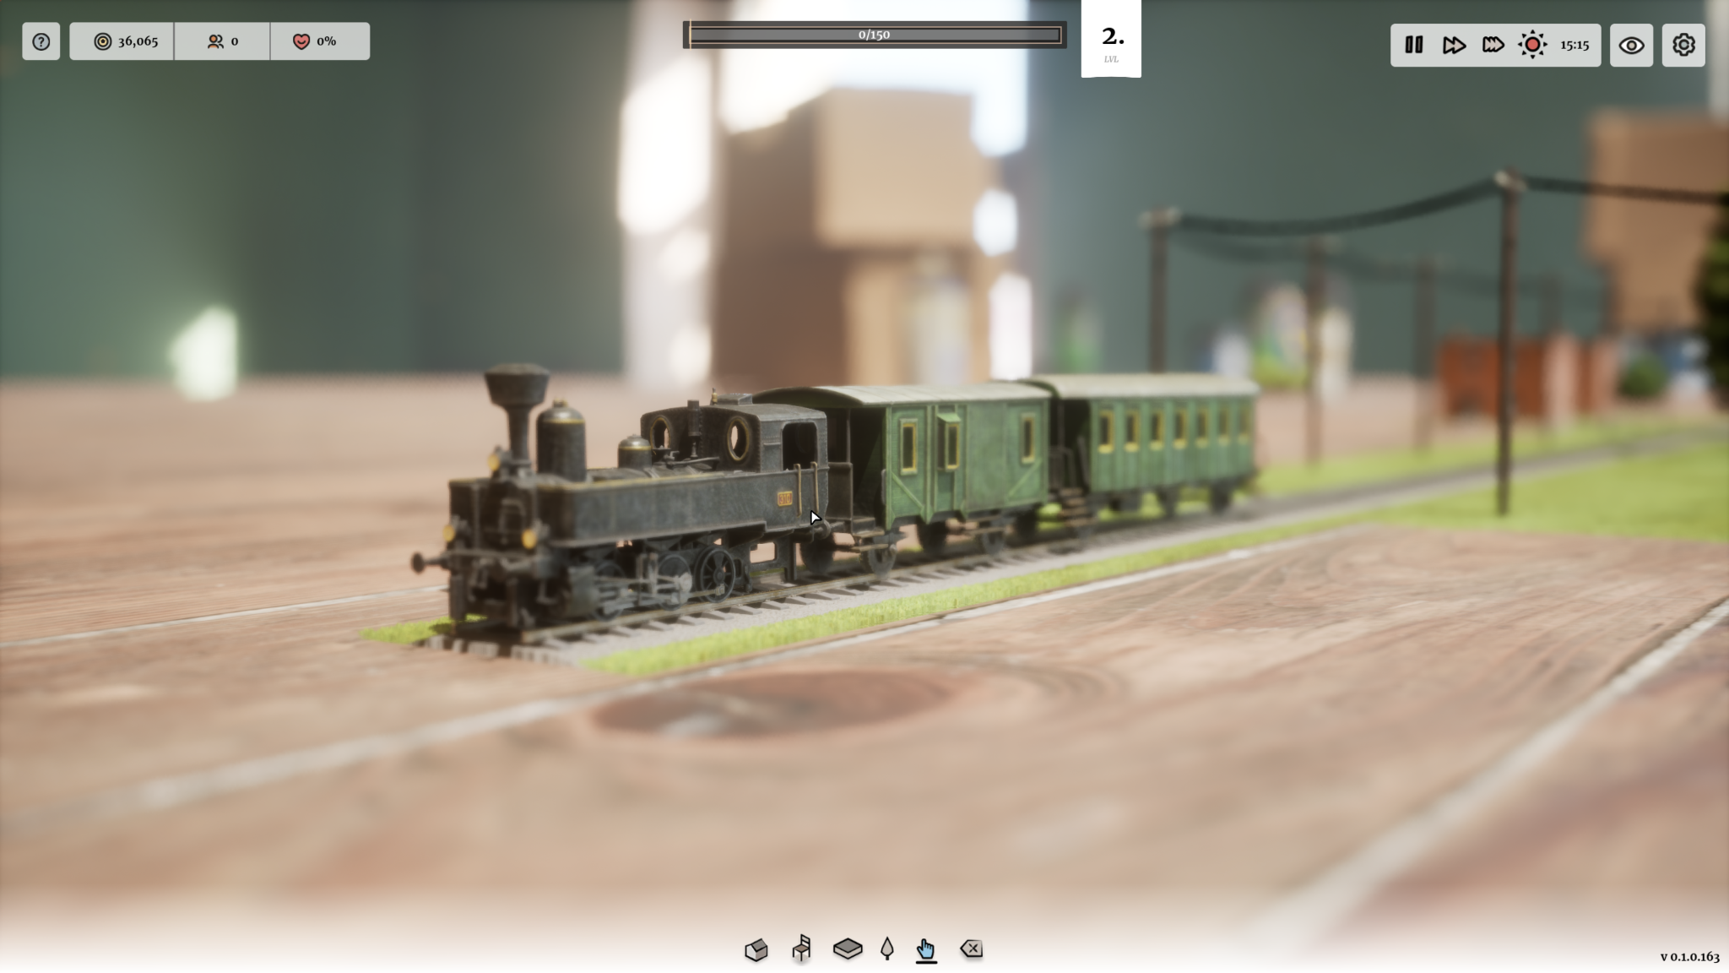

EDUCATIONAL
The game encyclopedia tells the story of great ideas, modern architecture, and historical figures. Listen to the sound recordings made by the actors from Zlín as they play.

HISTORIC EVENTS
The game brings a new perspective and explores the fate of ordinary people in extraordinary times. A poor boy from the village becomes a master, and a young couple gets a family house.

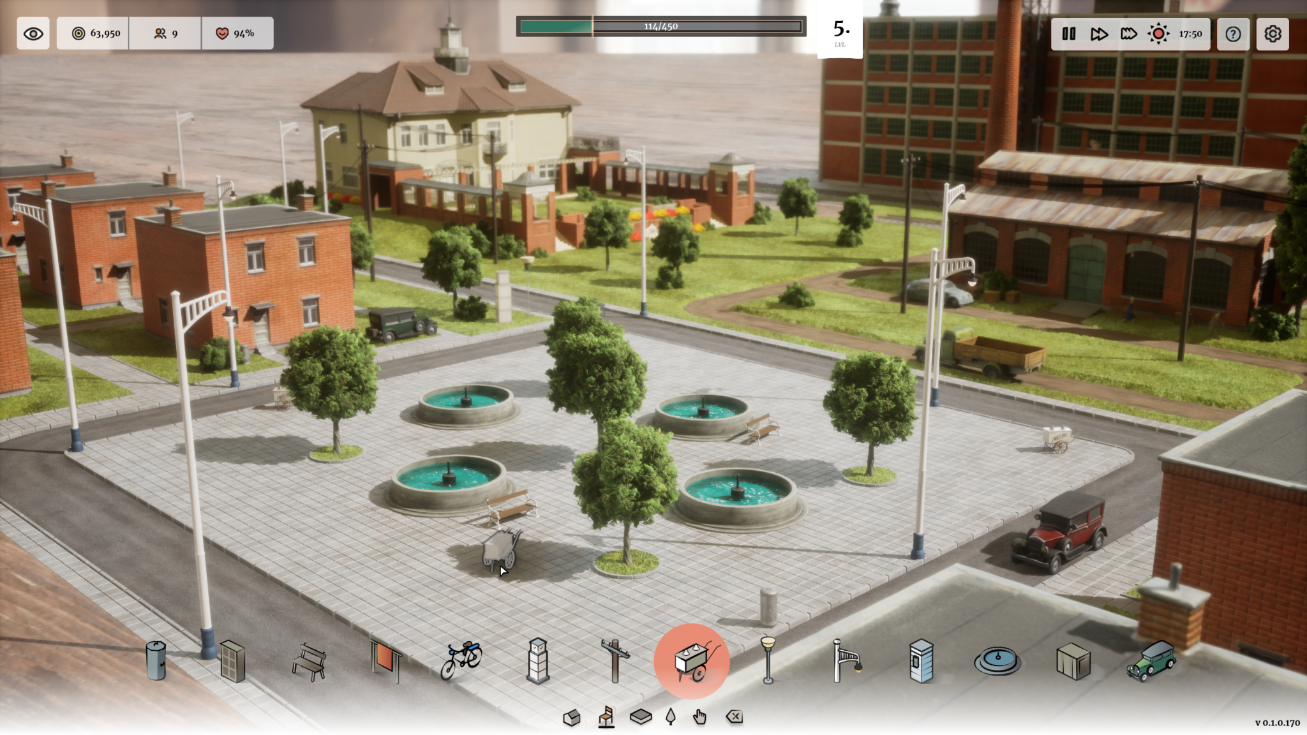

ORIGINAL SOUNDTRACK
A fantastic period-inspired score performed by the local orchestra, capturing the charm and atmosphere of the 1930s–1940s era.

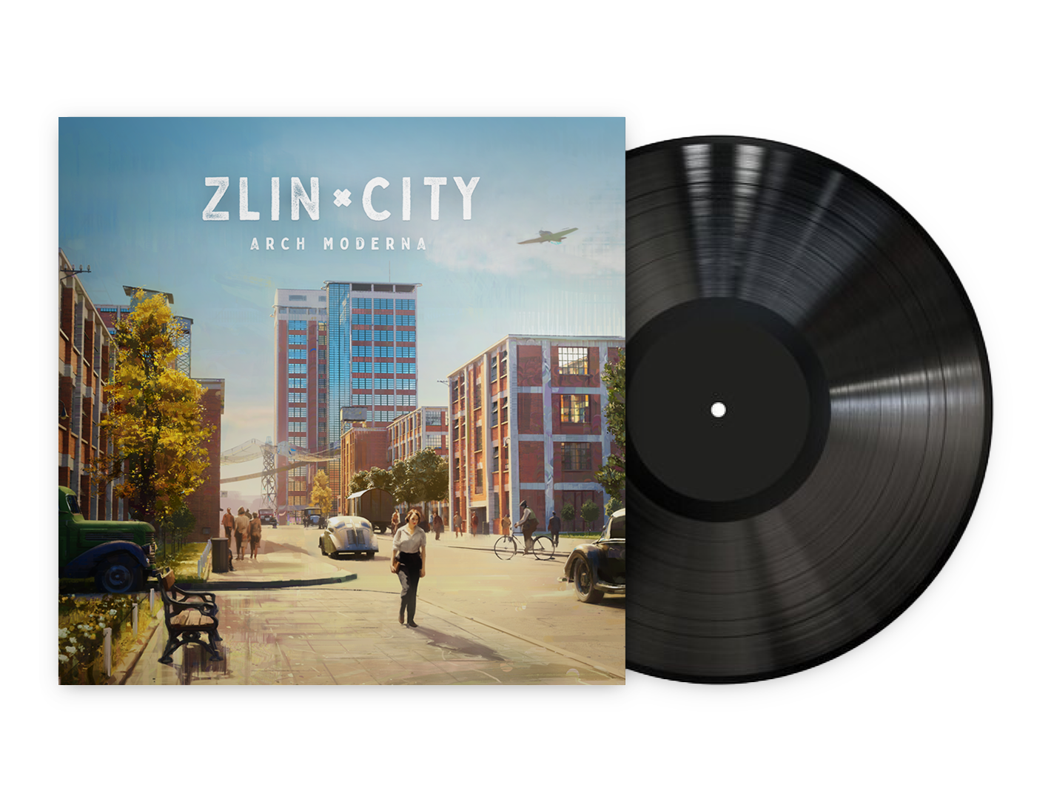

The Team
Polyperfect is a small, award-winning, independent game studio that initially specialized in creating tools for game developers, providing them with knowledge, assets, and inspiration. Its passion is crafting unique and visually stunning games with deep, engaging stories.
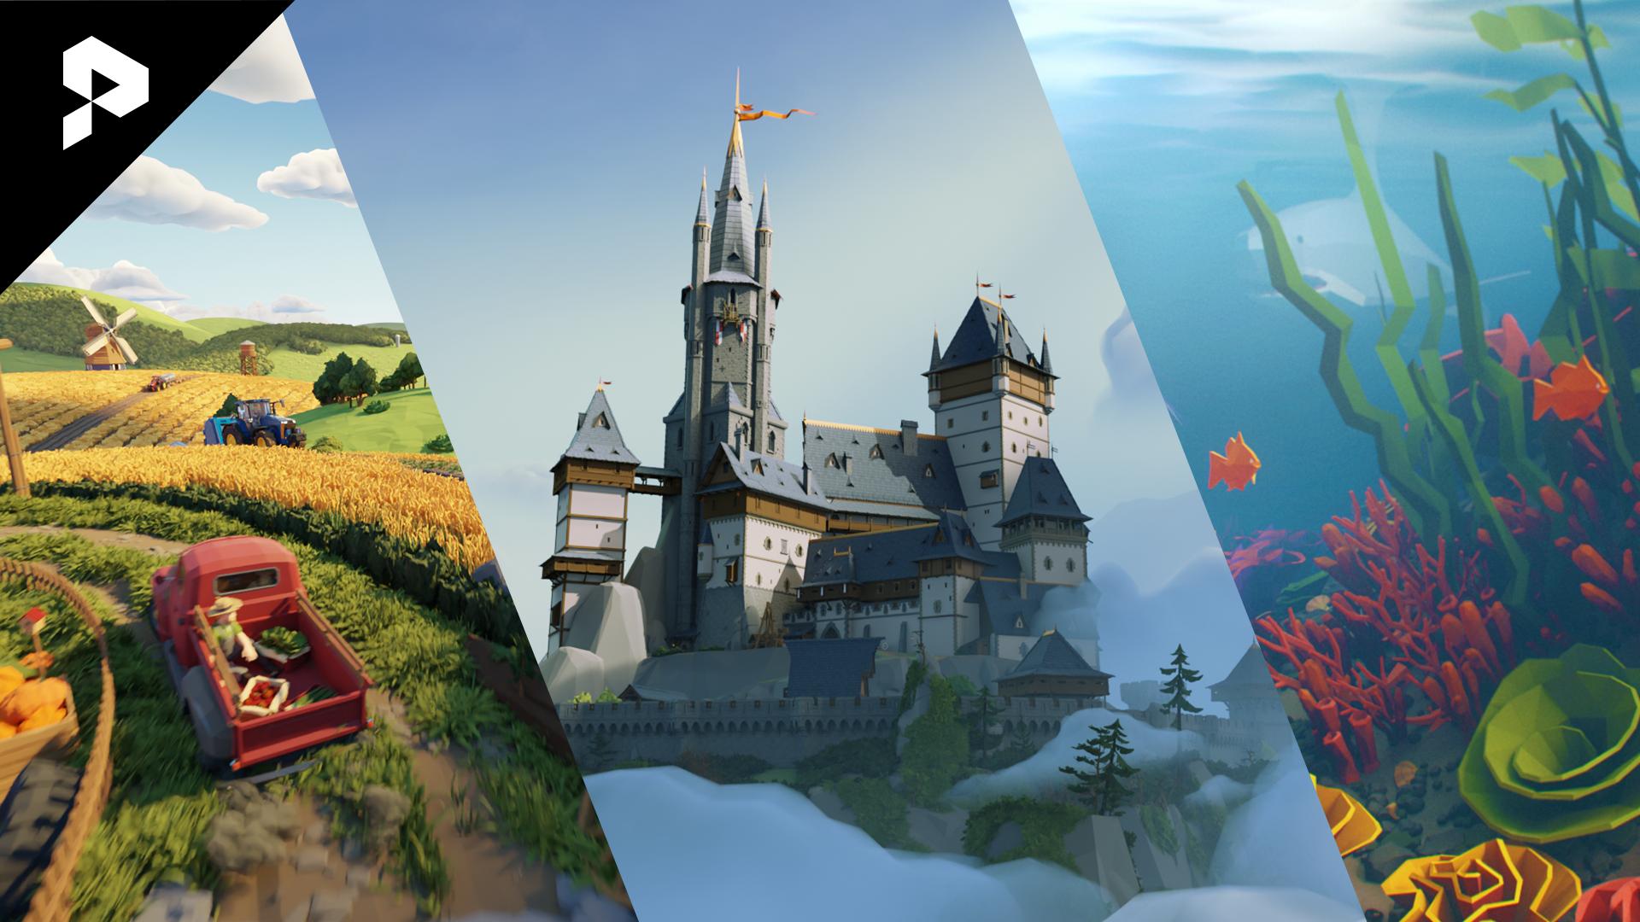

Links

Project website
https://www.zlincity.com/

Steam Page
https://store.steampowered.com/app/3017770/Zlin_City_Arch_Moderna/
Socials
https://x.com/zlincity
https://www.instagram.com/zlincitygame/
Discord:
https://discord.gg/polyperfect

