Liberté will soon leave Early Access!

SuperStatic Studio announces, that their deckbuilding, action roguelite Liberté, will leave Early Access on April 6th, following a several months of community-driven game development, hundreds of hours of playtesting and countless content and mechanics additions.

Release date trailer:
https://youtu.be/SdPj2Y-S9_M

Liberté is a deck-builder roguelite set in Paris during the times of the French Revolution. Brave the war-torn streets as Rene - a regular Parisian entangled in a massive intrigue between the four most influential factions in the city. Collect cards, nurture alliances and discover the truth behind the city’s cryptic invader from another dimension, Lady Bliss.

Build your unique playstyle with cards & skins
Mix and match from over 100 Skills and Talents cards. Go full-on guns-blazing, cut your way out with blades and axes, hit your enemies with a guitar, and sing the revolutionary song! Lead Rene in his human form or use the skin-shifter ability to play as one of the characters - Master Hunter Victor, Tribal Warrior Flea, or Revolt Leader Ana. You’ll encounter mighty enemies too, and face the curses of the Bliss, so make sure to come to the battlefield prepared.
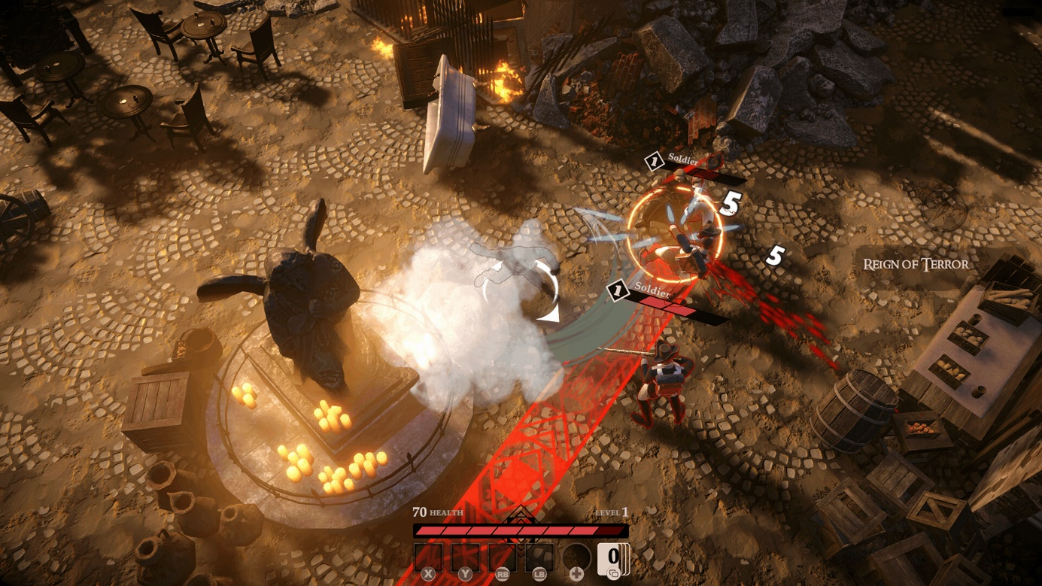

Unravel the horrifying mystery of the Bliss
Lady Bliss came out of nowhere and nestled hidden in the Bliss - a Cronenbergian netherworld that only you can access. Guarded by the all-mighty Eldritches, the gardens of the Bliss are dangerous places. But as you do the monster’s bidding, you will uncover the mystery of who Lady Bliss is and why she chose you for her secret mission.
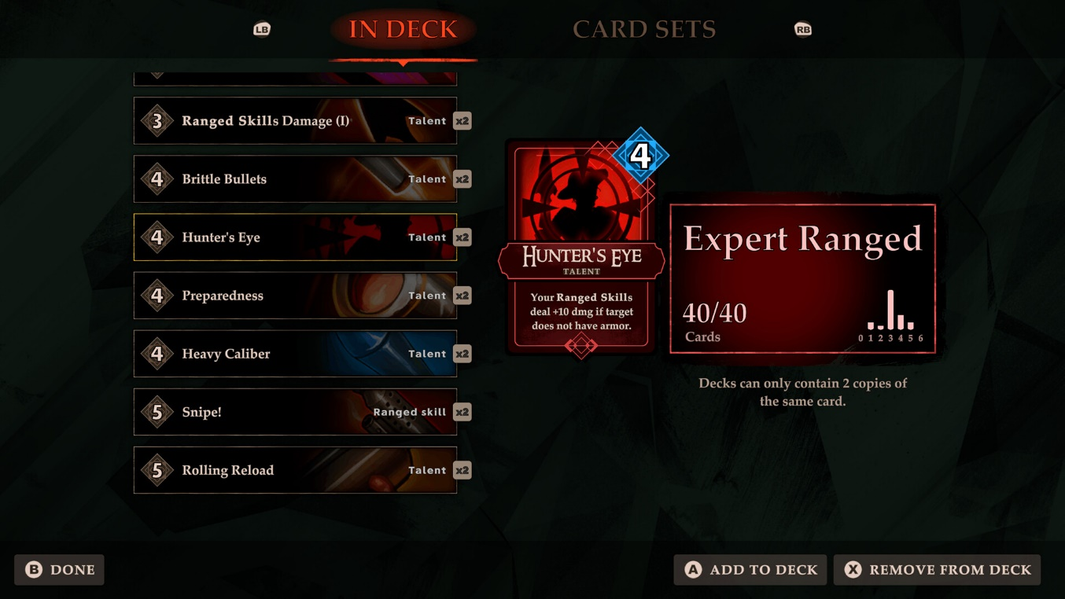

Immerse yourself in over 40 hours of dialogues
Inspired by the real French Revolution events, characters, and architecture, Liberté pulls you into a world on the brink of annihilation. Over more than 40 hours of gameplay, you will witness body horrors, participate in political maneuvers, and attempted assassinations, and see Madam Guillotine leaving a trail of blood.
Main features:
- Action Roguelite meets deckbuilder - players unlock cards and build decks that unlock skills, passives and game changing mechanics to make their avatars stronger
- Four unique factions to support – choose the side of a conflict to unlock additional rewards
- Greatly varied enemies and advanced AI - Trained soldiers fight in formations, Tribesmen protect their Shamans, Rebels use fire to cut off enemies, etc
- A unique setting - Revolutionary France mixed with body horror theme
- Mature storyline, with complex, shades-of-gray characters and horror elements
- Full controller support
As you read, Superstatic Studios has issued a major content update to the Early Access build of Liberte, adding 13 new story areas and over 200 unique story encounters with over 2,500 new lines of dialogue. As for the gameplay layer: three new story bosses have been added for demanding players, and some quality-of-life improvements will occur to improve the overall gameplay experience.

ASSETS
All promo materials are available at this link: https://1drv.ms/u/s!AjqtyACv3eKUwG14fU-7ycDet_TN?e=vxPlnG

MEDIA CONTACT
Anshar Publishing
Mateusz Greloch – Publishing Manager
E-mail: mateusz.greloch@ansharpublishing.com
Twitter: @MateuszGreloch
General press inquiries: press@ansharpublishing.com

About SuperStatic Studio
Poland-based indie studio of passionate game developers. Liberte is their second published title. They pride themselves on creating a captivating, shades-of-gray world filled with colorful and intriguing characters.

About Anshar Publishing
Anshar Publishing focuses on providing comprehensive marketing and publishing services for PC and console games.
We believe that marketing deserves craftsmanship and an individual approach to each project, based on the expertise of our team professionals. Created in 2021, the team consists of Anshar Studios veterans and experienced specialists who gained their understanding of the industry at key Polish game studios.
Apart from experience, we are a group of passionate gamers with an openness to support independent developers and increase the visibility of their hidden gems. We are ready to be challenged and pave the way to your target audience.
More info at: http://www.ansharpublishing.com

