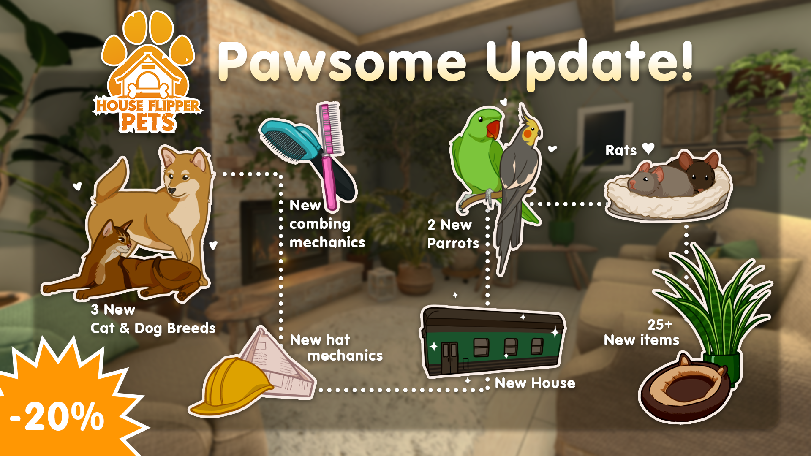
Title: The much-anticipated addition of rats, new cats, dogs, parrots, and more! All thanks to the Pawsome Update!

[trailer]

Standfirst:

Since the release of the House Flipper - Pets DLC, the developers at Frozen Way and Frozen District have been as busy as popcorn on a skillet. Although the DLC has sold thousands of copies, the developers have been working hard on brand-new content-related features. Please welcome the Pawsome Update!

For immediate publication – 14/07/2022 – Cracow, Poland

Thanks to the Pawsome Update, players will be able to take care of three brand-new cat and dog breeds. This includes Dalmatians, Shiba Inu (yep, the one from the memes), and Chihuahuas. As for cats, the players will have the pawsibility to look after Turkish Angora, Abyssinian, and orange tabby cats.

But that's not all – start preparing a housewarming party, because your long-awaited rat friends are coming to Cozy Village. The developers also prepared something extraordinary for those of you eagerly awaiting more exotic pets. From now on, players will have the ability to flip houses together with new parrots – the cockatiel and ring-necked parakeet. Speaking of house flipping, the developers will also introduce a new train car house, which might hide a little secret. Curious to see what it could be? Then wait no longer and visit Cozy Village!

[screenshots]

The Pawsome Update comes with:

- A 20% discount on Pets DLC
- Three brand-new breeds of cat and dog
- Two new parrots
- Rats
- The ability to comb dogs, kitties, and bunnies
- Optional hats for your pets
- Dogs jumping and sitting on a selection of beds and sofas
- A brand-new train car house for you to flip
- 25+ new items at your disposal
- And much, much more!

If you still didn't manage to grab a copy, now is the perfect time. And last but not least, don't forget to follow the developers' social media channels if you want to stay up-to-date with any news.

About Frozen District:

Frozen District is a group of gamers with personalities passionate about virtual entertainment. Regular people who are still ready to pull some all-nighters playing their favorite titles. Since we're part of the gaming community, we know what gamers need. We fulfill our ambitions by creating projects that we ourselves would want to play.

At the same time, all of us want to be the best at what we do, aiming for peak performance by polishing our skills and seeking innovative solutions. That's why you'll find experts in programming, marketing, graphics, design, and much more in our midst. Our main priority is constant improvement and crafting all of these valuable experiences into the uniqueness present in our current and upcoming titles.

About Frozen Way:

We are a development studio and publisher from Cracow. You may know us from co-creating House Flipper, as well as creating and releasing House Flipper VR and the House Flipper - Pets DLC on Steam. We're a group of friendly people with a passion for video games. Gamedev is our lifestyle and philosophy, so there's nothing better than seeing our creations bring joy to the community. In the end, we're all nerds, aren't we?

