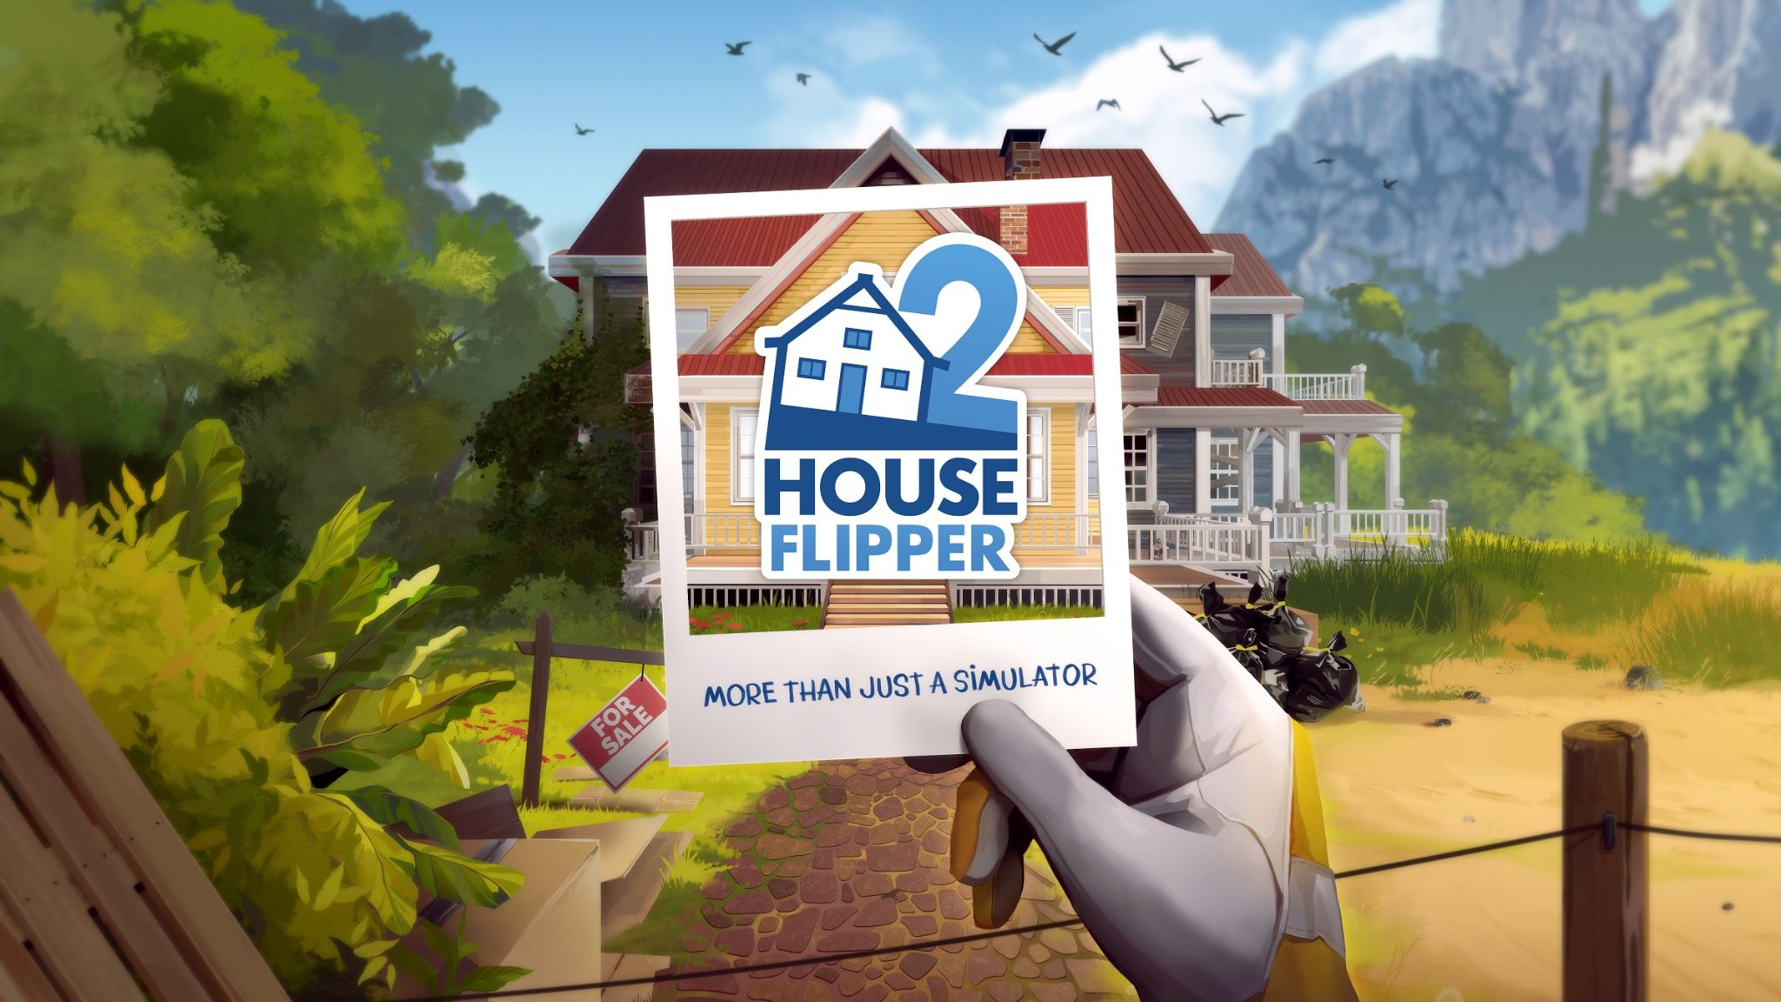

Frozen District Announces Spring Update for House Flipper 2 with Fresh Trailer, Delays Console Launch

This spring, Pinnacove welcomes exciting new content and recognition in a fresh trailer, as the console debut of House Flipper 2 is postponed to April 10th.

Kraków, Poland - March 6th, 2024 - Following the celebrated release of House Flipper 2 in December, Frozen District has now unveiled the game's Spring update and a new accolades trailer. Additionally, the studio has revised the console edition launch of House Flipper 2 to April 10th. This Spring Update introduces various new interior options, decorative pieces, and a novel task to Pinnacove's seaside setting. The latest trailer compiles some of the finest feedback from leading industry publications. Catch the trailer below!

Watch the House Flipper Spring Update trailer HERE.

Frozen District has also shifted the console version release of House Flipper 2 from its initial March 21st date to April 10th. This adjustment grants the development team additional time to refine the game for console certification. This ensures that the Spring and April Fool’s Day updates (scheduled for April 1st) are available to console players upon release.

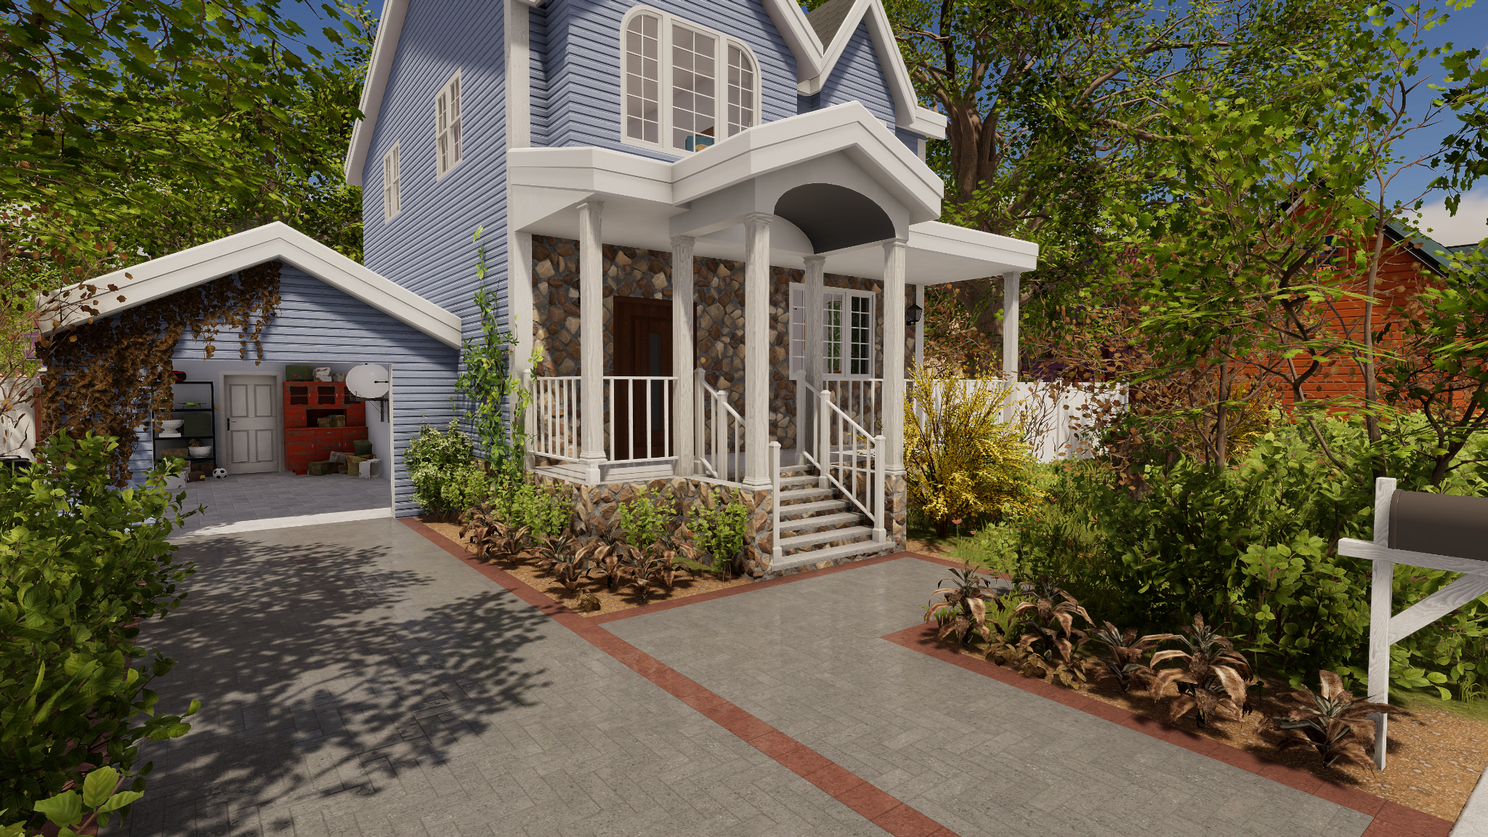

Not sure if the console version of House Flipper 2 is worth the wait? Watch the Accolades Trailer HERE.

The Spring update enriches the game with new furnishings, decorations, and gameplay features, delivering highly anticipated content to the community.

New Items:
- Chic curtains and flooring options, including uniquely laid carpets
- Sophisticated blinds, along with lifelike flames for fireplaces and candles
- Spring-exclusive order items, a useful ladder, and snug pillows for extra comfort

Enhanced Mechanics:
- Relish the ability to rest in beds to restore your character's energy
- Directly sell stairs and roofing in the campaign
- Adjust the size of objects in Flipper Mode to ensure they fit perfectly in any area

Exciting Additions:
- Greet 4 new buyers, each presenting distinct tastes and requirements
- Check out a newly available house and tackle a fresh mission order
- Take on a special task from Nico and Carol to make their residence a bastion of well-being!

House Flipper 2 builds on the original game’s design and management mechanics with new features and a thorough revamp of existing systems. All are showcased in a vibrant visual style.

For more news, follow House Flipper 2 on Twitter and Facebook, or visit the store pages: Steam, PlayStation store, and Microsoft store.

About House Flipper:
The House Flipper games are casual, family-friendly design simulators that let players use their creativity and ingenuity to repair, remodel, and renovate run-down houses. More than a simulator, House Flipper games encourage players to relax, express their creativity, and build strong communities. The first House Flipper game sold over 5M copies across PC, Nintendo Switch, PlayStation 4, and Xbox One. House Flipper 2 upgrades the original title with polished mechanics, crisp new graphics, plus new gameplay modes: Sandbox and Story Modes. Currently available on PC, House Flipper 2 will launch on consoles in 2024.

About Frozen District:
Frozen District is a group of gamers—personalities full of passion for virtual entertainment—regular people who are still ready to pull some all-nighters playing their favorite titles. We know what gamers need, as we are a part of the gaming community, and through creating our projects, which we would play ourselves, we fulfill our ambitions. At the same time, we all want to be the best at what we do, still trying to reach the peak of our performance by polishing our skills and seeking innovative solutions. That is why you can find programming, marketing, graphics, design, and many more experts in our midst. Our main priority is constant improvement and crafting all the valuable experience gathered this way into the uniqueness present in our current and upcoming titles.

