Email Subject Line: Gamedec returns as Definitive Edition on PC on September 29th this year!
Gamedec returns as Definitive Edition on PC on September 29th this year! New cases and new characters are waiting to dive into virtual worlds again.

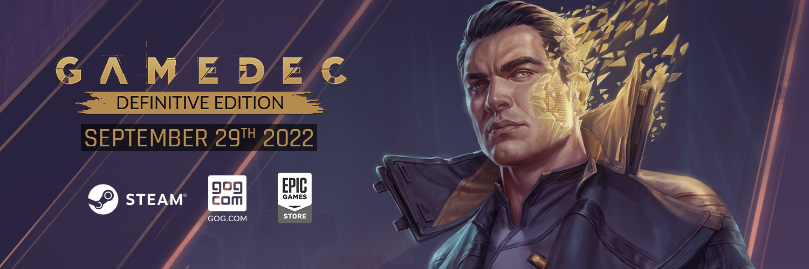

FOR IMMEDIATE RELEASE – September 16th, Katowice, Poland.

Exactly one year ago, Gamedec premiered on PC. On September 29 this year, players will be able to take on the role of gamedec again with the release of the Definitive Edition. Players can expect new playable content, including a virtual world based on Seven: The Days Long Gone, additional characters and True Detective Mode, which will ensure that the decisions you make cannot be undone by loading a save.
Gamedec - Definitive Edition will be available for free to all PC players with the title in their library, regardless of the store. The game will automatically be updated, giving immediate access to new content. Players owning the game on the Nintendo Switch console will have to be patient for a few more weeks. Our Japanese fans can also finally try the game with fully translated texts. The JP localization will be live with a Definitive Edition update.
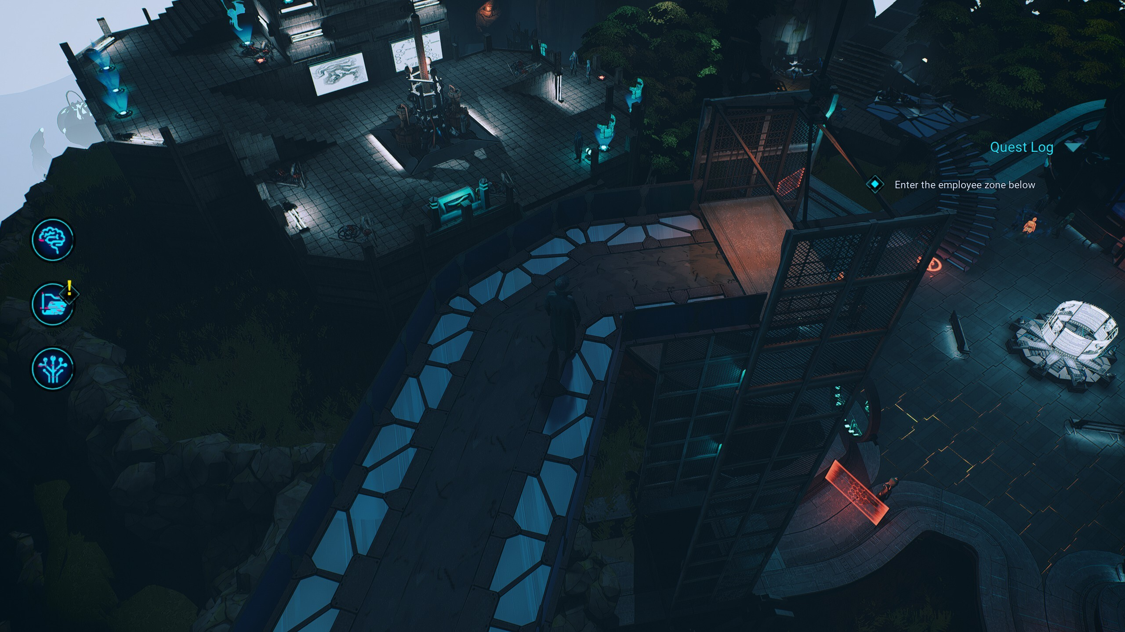
ABOUT GAMEDEC
Gamedec is an authentic RPG experience where every decision is important and comes with consequences. The world in which you live adapts to each decision you make. As the story progresses, your hero adapts as well. Just like in “real” life, the consequences of your choices can be immediate, long-term, or stay hidden, surfacing only when you least expect them. Whatever you decide, the game will remain neutral without judging your choices or suggesting “better” options. It is up to you to evaluate what you’ve done. Just remember that in this job, the game is always on.
Anshar Studios returns to the foundations of the RPG genre with their new game, built on mechanics such as Deduction, the Codex, and Aspects. These allow for complex conversations and interactions as players create or expose networks of conspiracies while discovering unusual relationships between virtual worlds. Gamedec’s pen-and-paper-based RPG mechanics give players the freedom to approach situations from multiple perspectives.

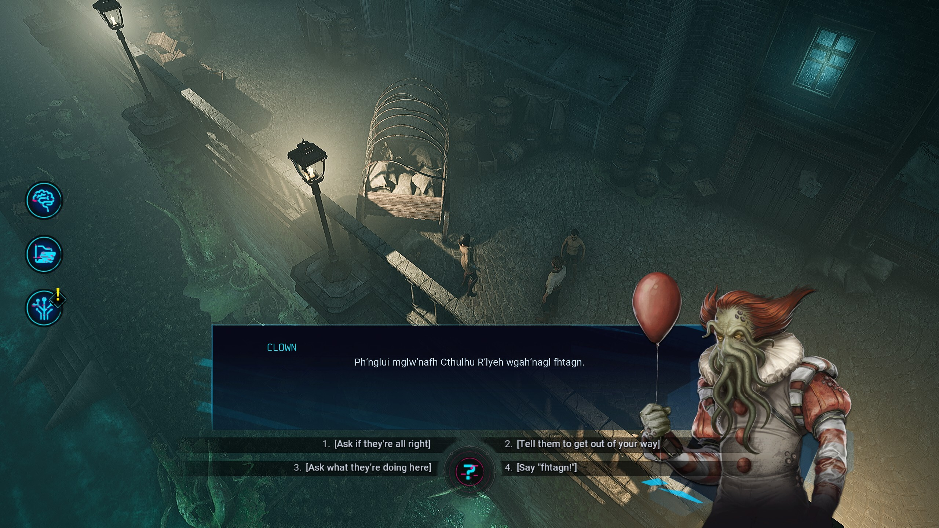

YOU ARE THE SUM OF YOUR CHOICES
Your goal is to hunt down the criminals of virtual worlds – rich and spoiled businesspeople, parents who want better lives for their children, corporations with plans to rewrite history. Are they acting alone, or are they mere puppets? What does a “happy ending” mean to you? To them? Each decision changes the world around you and your character’s personality. Some decisions will feel right, but others might be unexpected.
EXPLORE THE CYBERPUNK OF THE 22ND CENTURY
Welcome to Warsaw City in the 22nd century, where “real” is relative and “life” and “death” have many meanings. Real and virtual worlds have merged, giving rise to ancient vices: lust, sloth, pride, envy… That’s why everyone needs gamedecs – specialists who solve real problems in virtual worlds. Be it the Wild West or a prehistoric amusement park, these and many other worlds reveal our inclinations and weaknesses.
EXPERIENCE THE ESSENCE OF ROLE-PLAYING
Use your wits to gather info from witnesses and suspects, get to the bottom of deceptive schemes, save lives, and investigate the extraordinary relationships between virtual worlds and their inhabitants. Gamedec emulates the nature of tabletop RPGs by focusing on character development through decision-making. As in classic tabletop RPGs, you’re given the freedom to approach situations from multiple angles, rather than forcing a single solution – the choice is yours, and yours alone.

More information can be found on the game’s official website, Facebook, Twitter, YouTube, and Discord.

The press kit is available for download HERE.

PREVIEW COPIES (PC) ARE NOW AVAILABLE. If you’d like to try your luck in Gamedec’s virtual worlds, please get in touch with Agnieszka Szóstak at agnieszka.szostak@pr-outreach.com or call +48 881 951 601.
___________________________________________________________________
About Anshar Studios
Craftmanship is our way. We follow the radical truthfulness philosophy to communicate and, as a result, bring impactful, first-party ideas to life and deliver perfected third-party projects. We have a skilled team, a well-crafted portfolio, and ambition to grow. We’re hungry to make good games.
Anshar Studios has also expanded the scope of our activities and offers services to many reputable companies in the video game industry. We have collaborated with clients such as Larian Studios, Bloober Team, Artifex Mundi, The Farm 51, Playway, and QLOC. The most recent Anshar first-party projects were Telefrag VR – a fast-paced PVP VR shooter, and Detached – a space exploration VR game. The studio is also involved in the development of a few undisclosed projects for a group of premium-tier customers. https://ansharstudios.com/

