Gamedec – Definitive Edition is now available on PC!
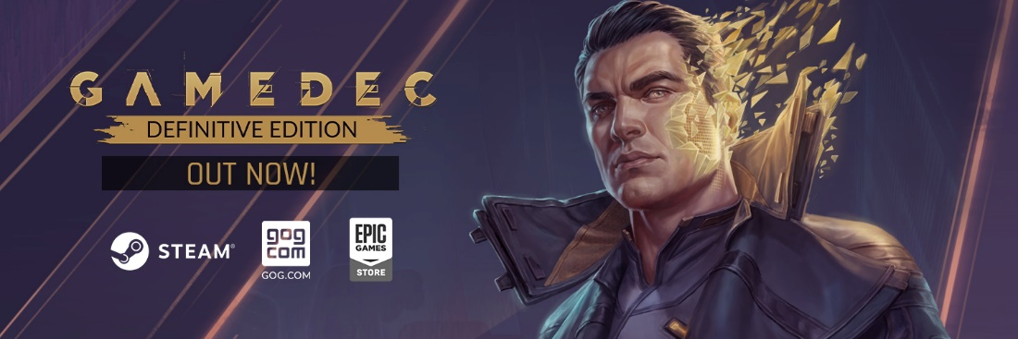

FOR IMMEDIATE RELEASE – September 29th, Katowice, Poland.
Explore the virtual worlds once again! Gamedec – Definitive Edition brings a fresh look to the current-existing cases! First, players can immerse themselves in the world based on Seven: The Days Long Gone, the game released in 2017 by Fool’s Theory and IMGN.PRO. The case is completely readable to those who played neither of these games thus offer a mouthful of additional flavor to those who did. Expect the brand new virtualium and even more challenging NPCs. Additionally, fans of the Cthulhu mood can take on a new twist in one of the current-existing cases. Ph'nglui mglw'nafh cthulhu R'lyeh wgah'nagl fhtagn!

WATCH GAMEDEC - DEFINITIVE EDITION LAUNCH TRAILER
https://youtu.be/AlNltSMwMe8

Gamedec - Definitive Edition is all about major tweaks that the game has received throughout the year. To summarize the post-launch support, the devs will release Free Characters Pack with new personas. Each of them has its strong sides and already allocated aspects. What’s more, the True Detective Mode will test your firmness. There is no chance to load the save and try to approach the conversation from a different angle. Will you try to face once again the challenges that await the residents of Warsaw City of the 22nd century? You should. One. Last. Time.
Gamedec – Definitive Edition will replace the current existing product in the stores. That means all the players with the game in their library will receive the update totally for free. The Nintendo Switch edition will be available later this year. Stay tuned for more details on our social media channels!

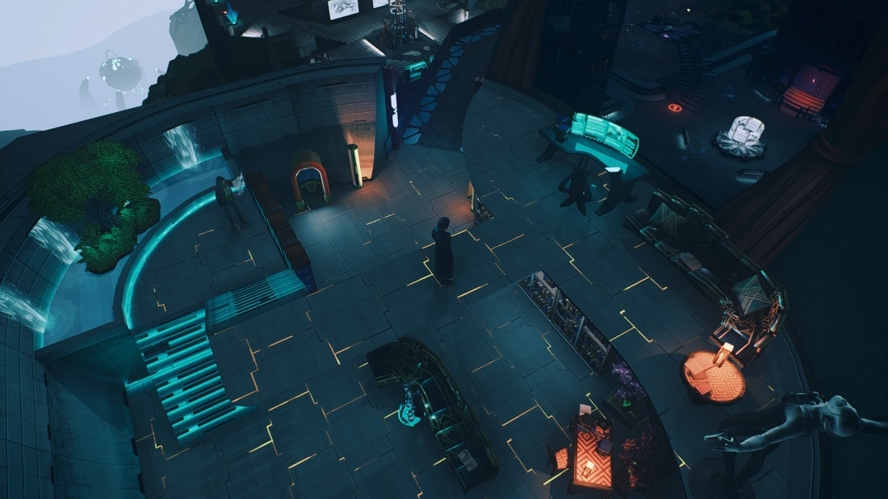
ABOUT GAMEDEC – DEFINITIVE EDITION
Gamedec – Definitive Edition is an authentic RPG experience where every decision is important and comes with consequences. The world in which you live adapts to each decision you make. As the story progresses, your hero adapts as well. Just like in “real” life, the consequences of your choices can be immediate, long-term, or stay hidden, surfacing only when you least expect them. Whatever you decide, the game will remain neutral without judging your choices or suggesting “better” options. It is up to you to evaluate what you’ve done. Just remember that in this job, the game is always on.
Anshar Studios returns to the foundations of the RPG genre with their new game, built on mechanics such as Deduction, the Codex, and Aspects. These allow for complex conversations and interactions as players create or expose networks of conspiracies while discovering unusual relationships between virtual worlds. Gamedec’s pen-and-paper-based RPG mechanics give players the freedom to approach situations from multiple perspectives.

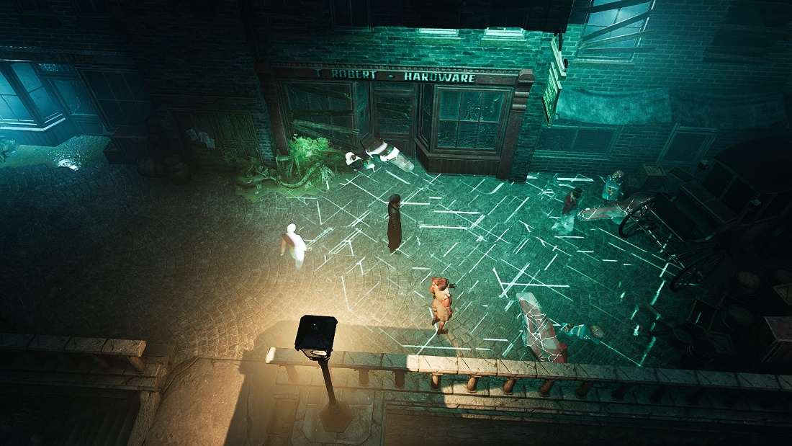

YOU ARE THE SUM OF YOUR CHOICES
Your goal is to hunt down the criminals of virtual worlds – rich and spoiled businesspeople, parents who want better lives for their children, corporations with plans to rewrite history. Are they acting alone, or are they mere puppets? What does a “happy ending” mean to you? To them? Each decision changes the world around you and your character’s personality. Some decisions will feel right, but others might be unexpected.
EXPLORE THE CYBERPUNK OF THE 22ND CENTURY
Welcome to Warsaw City in the 22nd century, where “real” is relative and “life” and “death” have many meanings. Real and virtual worlds have merged, giving rise to ancient vices: lust, sloth, pride, envy… That’s why everyone needs gamedecs – specialists who solve real problems in virtual worlds. Be it the Wild West or a prehistoric amusement park, these and many other worlds reveal our inclinations and weaknesses.
EXPERIENCE THE ESSENCE OF ROLE-PLAYING
Use your wits to gather info from witnesses and suspects, get to the bottom of deceptive schemes, save lives, and investigate the extraordinary relationships between virtual worlds and their inhabitants. Gamedec emulates the nature of tabletop RPGs by focusing on character development through decision-making. As in classic tabletop RPGs, you’re given the freedom to approach situations from multiple angles, rather than forcing a single solution – the choice is yours, and yours alone.

More information can be found on the game’s official website, Facebook, Twitter, YouTube, and Discord.

The press kit is available at the following link: https://pr-outreach.com/en/game/gamedec-definitive-edition,19.

REVIEW COPIES (PC) ARE NOW AVAILABLE. If you’d like to try your luck in Gamedec’s virtual worlds, please get in touch with Agnieszka Szóstak at agnieszka.szostak@pr-outreach.com or call +48 881 951 601.
___________________________________________________________________
About Anshar Studios
Craftmanship is our way. We follow the radical truthfulness philosophy to communicate and, as a result, bring impactful, first-party ideas to life and deliver perfected third-party projects. We have a skilled team, a well-crafted portfolio, and ambition to grow. We’re hungry to make good games.
Anshar Studios has also expanded the scope of our activities and offers services to many reputable companies in the video game industry. We have collaborated with clients such as Larian Studios, Bloober Team, Artifex Mundi, The Farm 51, Playway, and QLOC. The most recent Anshar first-party projects were Telefrag VR – a fast-paced PVP VR shooter, and Detached – a space exploration VR game. The studio is also involved in the development of a few undisclosed projects for a group of premium-tier customers. https://ansharstudios.com/

