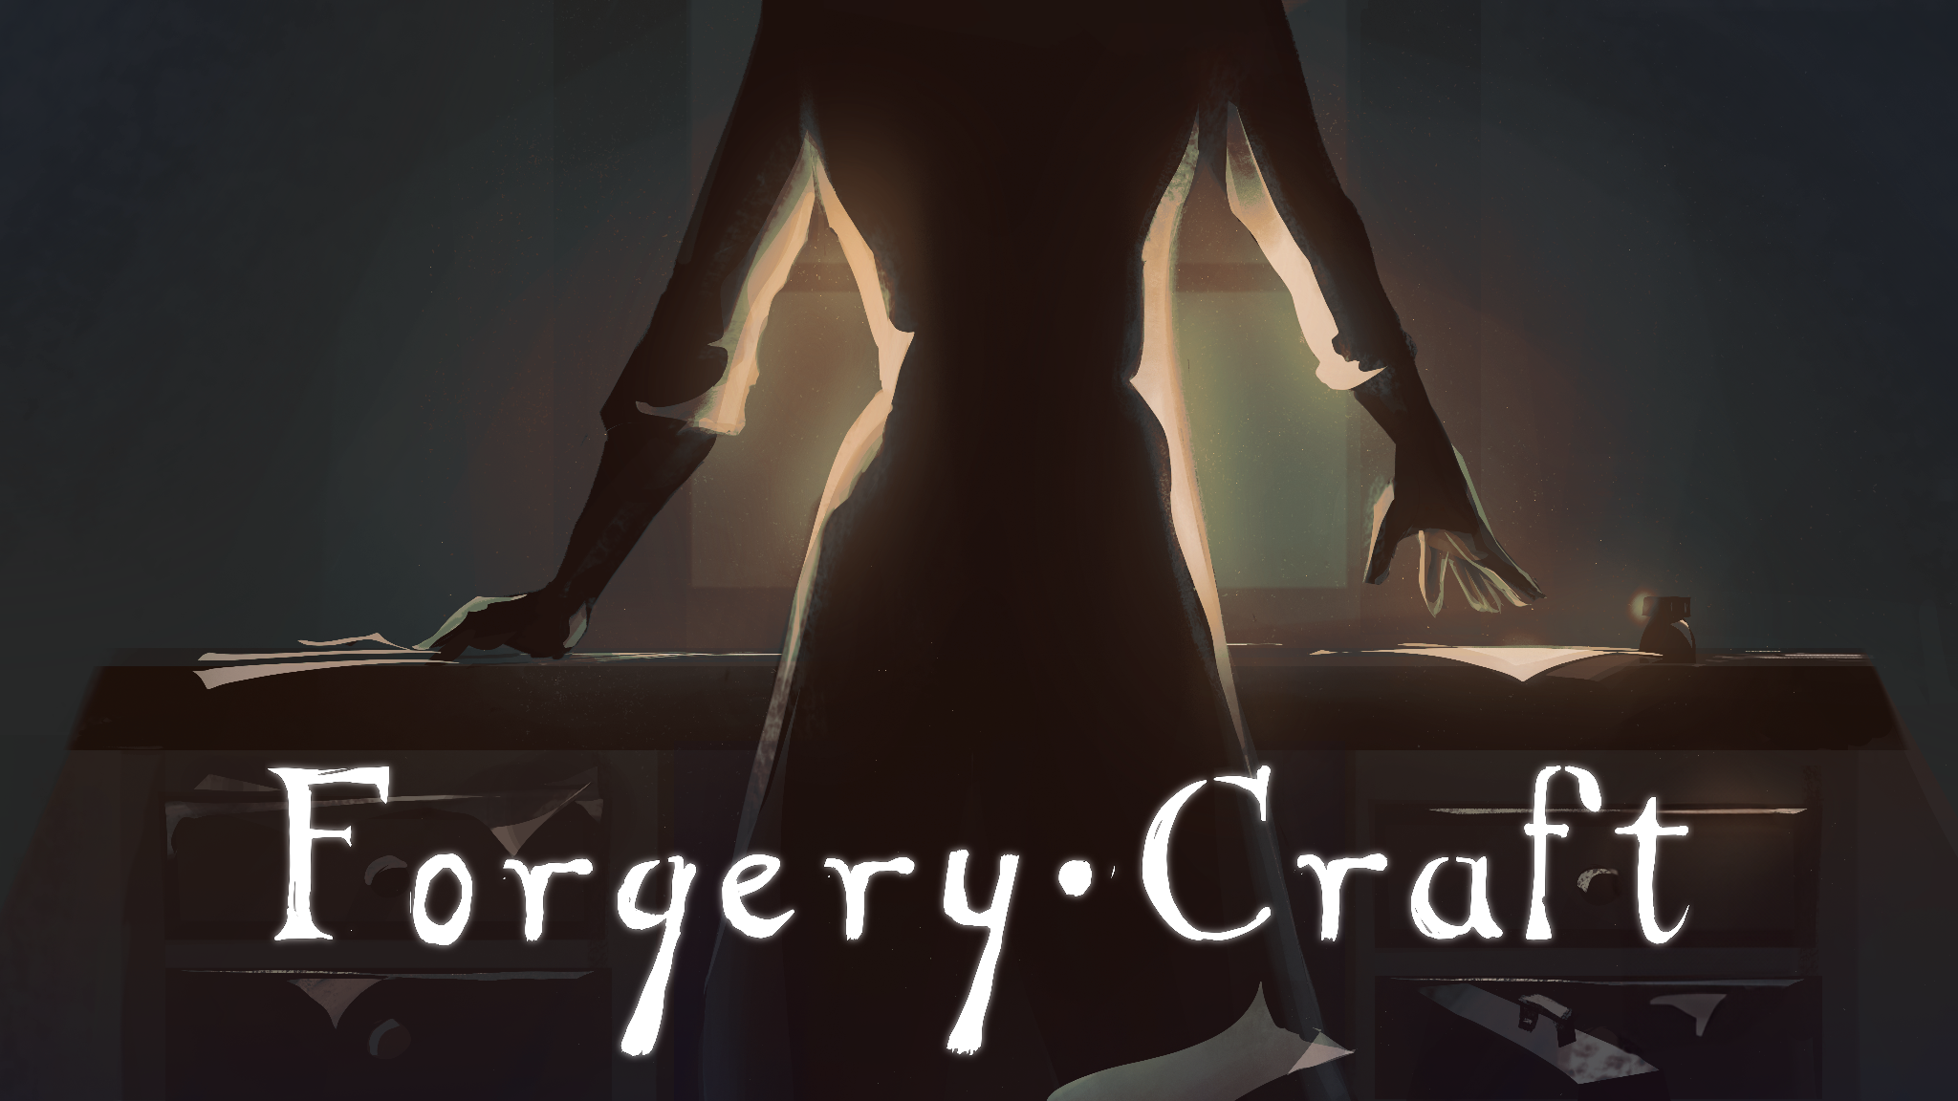

Discover the Thrill of Forgery in 'Forgery Craft’. Frozen District published the Steam page of the new game
Cracow, 10th November 2023 – Frozen District, the studio behind House Flipper and House Flipper 2, is excited to announce the Steam page launch of the newest game they publish, "Forgery Craft”.
This unique simulation game, which allows players to delve into the world of forgery, is now available for addition to Steam wishlists (https://store.steampowered.com/app/1540720/Forgery_Craft/). The game's official release date is yet to be revealed, but the anticipation is building.
Watch the Gameplay Trailer
"Forgery Craft" offers an engaging narrative where players step into the shoes of Amelia, an artist who turns her talents to the world of forgery. This game pushes the limits of creativity and deception, offering a unique take on the simulation genre.
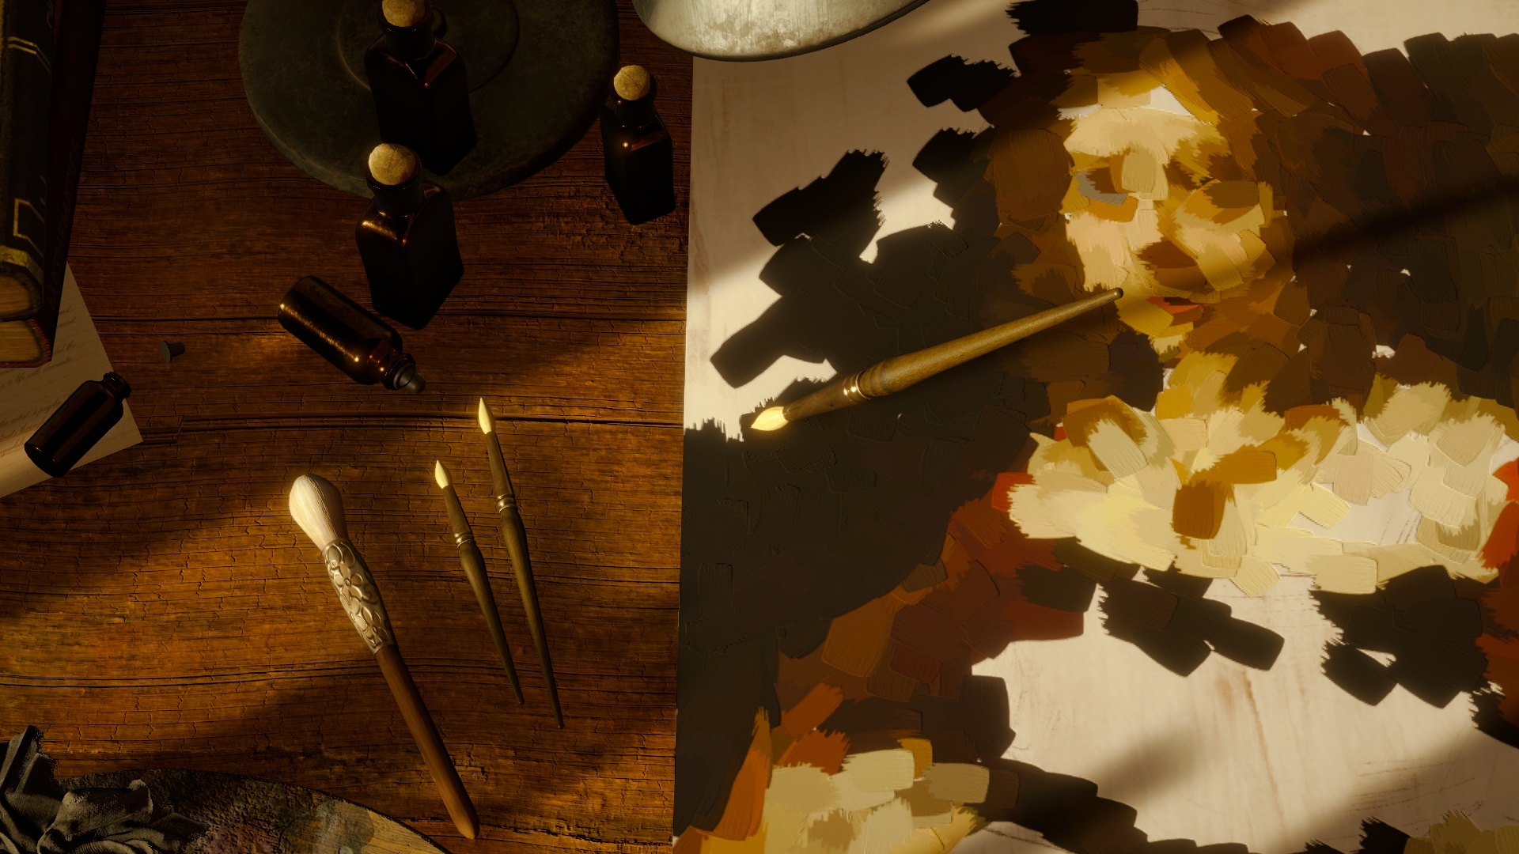
Main features:
- Engaging Storyline: Journey with Amelia as she transitions from a traditional artist to a master forger, challenging the conventions of art and authenticity.
- Mastering Forgery: Start with simple document alterations and advance to create art pieces that could deceive any expert. Experience the thrill of tricking art connoisseurs.
- The Art of Persuasion: A successful forgery isn't just about the artwork; it's also about selling the lie. Choose your words wisely to convince others of the authenticity of your creations.
- Expanding Your Toolset: As your forgery skills grow, so does your toolset. Discover new tools and learn how to use them to improve the quality of your forgeries.
- Creative Aging Techniques: Learn to age your creations effectively. Utilize everyday items to make your art pieces look centuries old, adding another layer of challenge to your craft.
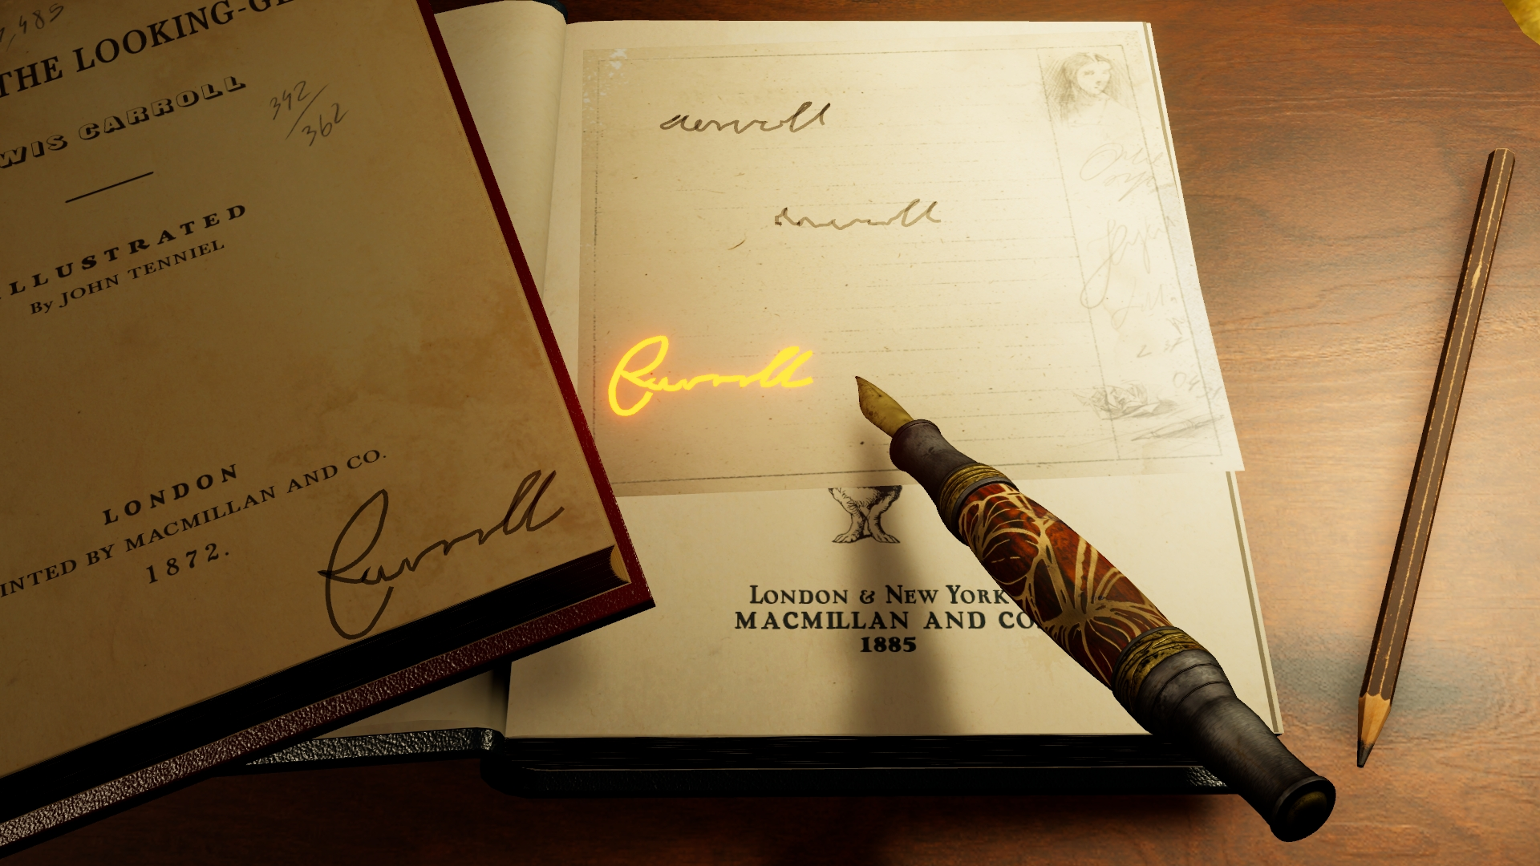
Add to Steam Wishlist: Gamers and art enthusiasts can now add "Forgery Craft" to their Steam wishlist (https://store.steampowered.com/app/1540720/Forgery_Craft/), ensuring they stay updated with the latest news and the game's release date.
About Frozen District: Frozen District is a group of gamers - personalities full of passion for virtual entertainment—regular people still ready to pull some all-nighters playing their favorite titles. We know what gamers need, as we are a part of the gaming community, and through creating our projects, which we would play ourselves, we fulfill our ambitions.
At the same time, we all want to be the best at what we do, still trying to reach the peak of our performance by polishing our skills and seeking innovative solutions. That is why you can find experts in programming, marketing, graphics, design, and many more in our midst. Our main priority is constant improvement and crafting all the valuable experience gathered this way into the uniqueness present in our current and upcoming titles.
Contact Information:
Michał Lewandowski, PR Specialist
michallewandowski@frozendistrict.com

