DAVY x JONES - FACT SHEET

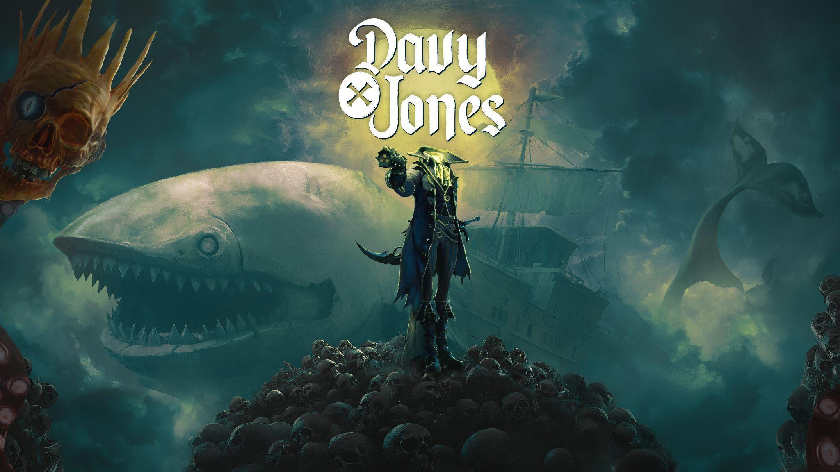
KEY FACTS:

Title: DAVY x JONES
Developer / Publisher: PARASIGHT / PARASIGHT
Platforms: PC (Early Access on Steam), Consoles (TBA)
Genre: First-Person, Action-Adventure, Revenge-Driven, Surreal, Inspiring, Dark Humor
Tags: Action, Adventure, First-Person, Open World, Singleplayer, Pirates, Dark Humor, Exploration, Surreal, FPS, Cinematic, Atmospheric, Dark Fantasy, Swordplay, Action RPG, Combat, Immersive
Setting: Pirate Underworld, Surreal
Release Date: 28th August 2025 on Steam (Early Access), Consoles TBD

LINKS:
STEAM: https://store.steampowered.com/app/2611170/DAVY_x_JONES/
WWW: https://parasight.studio/davyxjones
FACEBOOK: https://www.facebook.com/DAVYxJONES
X: https://x.com/DAVYxJONESgame
YOUTUBE: https://www.youtube.com/c/theparasight
DISCORD: https://bit.ly/DAVYxJONES_Discord
DAVY x JONES


Ascend to the highest fathom of a pirate underworld with the infamous Davy Jones on this action-packed, revenge-driven journey. Control the captain's headless body, stay on pace with his autonomous skull and keep his legend alive.
ABOUT THE GAME
Betrayed, robbed, and beheaded, legendary pirate Davy Jones sinks to The Locker — the seafarers’ afterlife. But death is merely the beginning of his epic tale of revenge. Control the captain’s headless body — Jones — and forge an unlikely alliance with his stubborn skull — Davy — as you reclaim your stolen artifacts and face your eternal nemesis: Blackbeard.
BODY x HEAD - A Fresh Take on the Legend of Davy Jones
Play as the infamous Davy Jones, split in two: his skull cracks wise and guides the way, while you command his powerful, headless body in a bizarre, unforgettable alliance.
THE LOCKER — PIRATES’ OPEN (UNDER)WORLD
Journey through The Locker, a surreal pirate hell shattered into nine islands floating on an infinite sea of clouds. Face twisted fiends, cursed souls and legendary behemoths like the Kraken — guardians of the underworld’s darkest secrets.
INTENSE SWORD, GUN, AND GRAPPLING HOOK COMBAT
Push through everything that stands in your way. Master fast-paced first-person combat with sword, gun and your own talking skull — and carve your path back into legend.
FUSIONS — Risk, Reward, and Mayhem
Every fallen enemy drops volatile underworld essence. When essences converge, they merge into a treasure chest containing powerful loot — but each chest also unleashes an unpredictable fiend. Will you take the risk… or flee before the storm?

ABBY — Your Living Vessel: Half Ship, Half Whale
Meet Abby: a young behemoth, hybrid of ship and whale who joins your epic journey. She’s your base, your artillery, and your ally. Recruit legendary Officers to crew her and unleash devastating abilities like CANNONS in combat.
FATHOM THE DEVIL

Grow into power and unlock your true nature —
because the only way out of Davy Jones’ Locker… is to BECOME THE DEVIL HIMSELF.
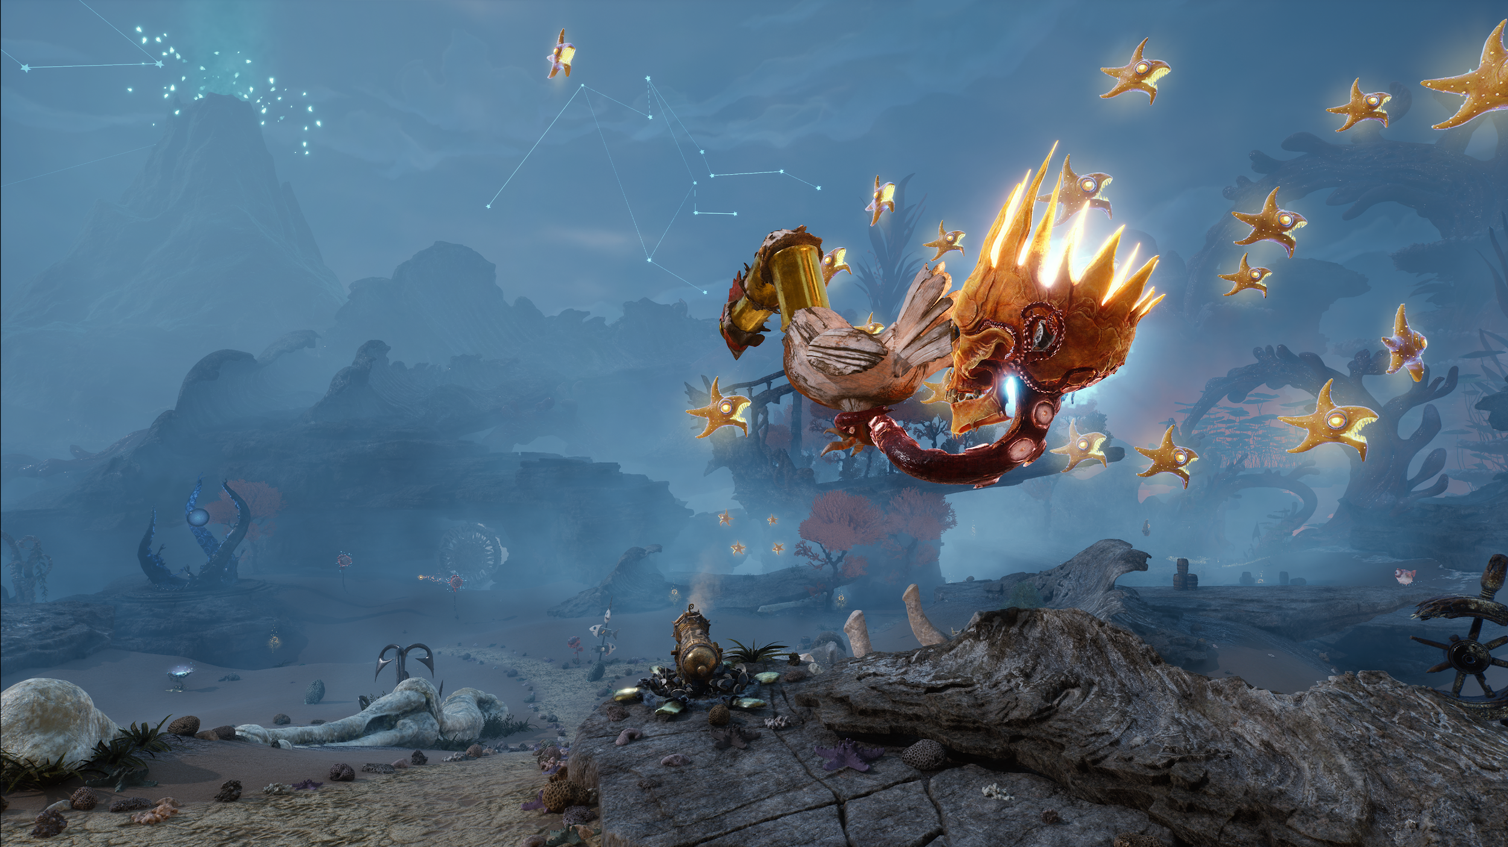
ASSETS:
All promo materials are available at this link: https://bit.ly/DAVYxJONES_PRESSKIT
MEDIA CONTACT:
Email: press@parasight.studio
PARASIGHT
General Inquiries about games - press@parasight.studio
ABOUT PARASIGHT
PARASIGHT is a studio founded by industry veterans, dedicated to crafting immersive, living worlds where story fuels action. We create bold, character-driven games that merge gripping narratives with dynamic gameplay—inviting players to carve out their own legends and discover the unexpected.
More info at: https://parasight.studio


