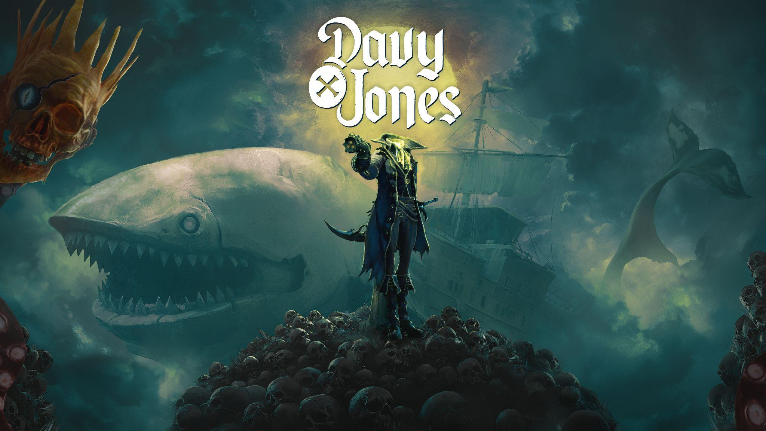
Plunder the depths of DAVY x JONES today on Steam Early Access
Only $6.66 for the first 6 days 6 hours and 6 minutes on sale
Kraków, Poland – August 28th – The crew at PARASIGHT, creators of the critically acclaimed BLACKTAIL, have today unleashed their demented and highly anticipated pirate-themed first-person action-adventure DAVY x JONES on Steam Early Access. That’s not all – the game’s price is mercilessly slashed to a mere $6.66 for its first 6 days, 6 hours, and 6 minutes on sale. (In layman's terms, this means the sale ends on September 4th). After that, the price rises to $9.99 / £8.50 / €9.75.

Check out the DAVY x JONES Early Access Trailer HERE.
In DAVY x JONES, players will step into the boots of the legendary pirate himself - betrayed, robbed, and ultimately - beheaded. Jones awakens in The Locker, a pirate hell shattered into islands floating on an endless sea of clouds. But death is merely the beginning of his epic tale of revenge. Control the captain's headless body — Jones — and forge an unlikely alliance with your stubborn skull — Davy — as you reclaim your legendary Artifacts and face your eternal nemesis: Blackbeard.
Fight like a true pirate legend, wielding sword, gun, and even your own sharp-tongued skull — whose tentacle makes for one hell of a grappling hook. Soar between cloud-swept islands aboard Abby, your half-ship, half-whale vessel, and face towering behemoths in desperate battles across the depths of The Locker. Rally your crew and avenge your honor by battling through hordes of cursed souls, fiends, and legendary pirates on your quest to escape the underworld!

This Early Access release will contain DAVY x JONES’ core gameplay and combat systems, Several of The Locker’s cursed islands, Legendary weapons, a host of underworld fiends, and variety of skills, cinematic executions and dynamic traversal. More content will be added throughout its voyage on Early Access, with the price increasing accordingly until the game’s full 1.0 launch on PC and consoles in late 2026.

“We wanted to give players the chance to climb aboard DAVY x JONES early - and secure it at a low price,” said Bartosz Kaproń, CEO and Creative Director at PARASIGHT. “Anyone who joins us in Early Access will own the full game at launch. But there’s already plenty of quality content to dive into: the first several islands of this adventure, with a core combat system, and a darkly enchanting pirate underworld ready to be plumbed. We’re a small crew of around 20 people, and every piece of feedback helps us refine and expand the game. Together with our community, we’re determined to make the final release a story worth telling.

Key features of DAVY x JONES:
- A Fresh Take on the Legend: Play as the legendary Davy Jones – his detached head guides, while the player commands his formidable body in an unforgettable alliance
- Pirates' Open (Under)World: Journey through The Locker, a surreal pirate hell shattered into nine islands floating on an infinite sea of clouds. Face twisted fiends, cursed souls and legendary behemoths like the Kraken — guardians of the underworld’s darkest secrets.
- Intense First-Person Combat: Push through everything that stands in your way. Master fast-paced first-person combat with sword, gun and your own talking skull — and carve your path back into legend.
- FUSIONS — Risk, Reward, and Mayhem: Every fallen enemy drops volatile underworld essence. When essences converge, they merge into a treasure chest containing powerful loot — but each chest also unleashes an unpredictable fiend. Will you take the risk… or flee before the storm?
- Your Living vessel ABBY - Half Ship / Half Whale: Meet Abby: a young behemoth, hybrid of ship and whale who joins your epic journey. She’s your base, your artillery, and your ally. Recruit legendary Officers to crew her and unleash devastating abilities like CANNONS in combat.
- FATHOM THE DEVIL: Grow into power and unlock your true nature — because the only way out of Davy Jones’ Locker… is to BECOME THE DEVIL HIMSELF.
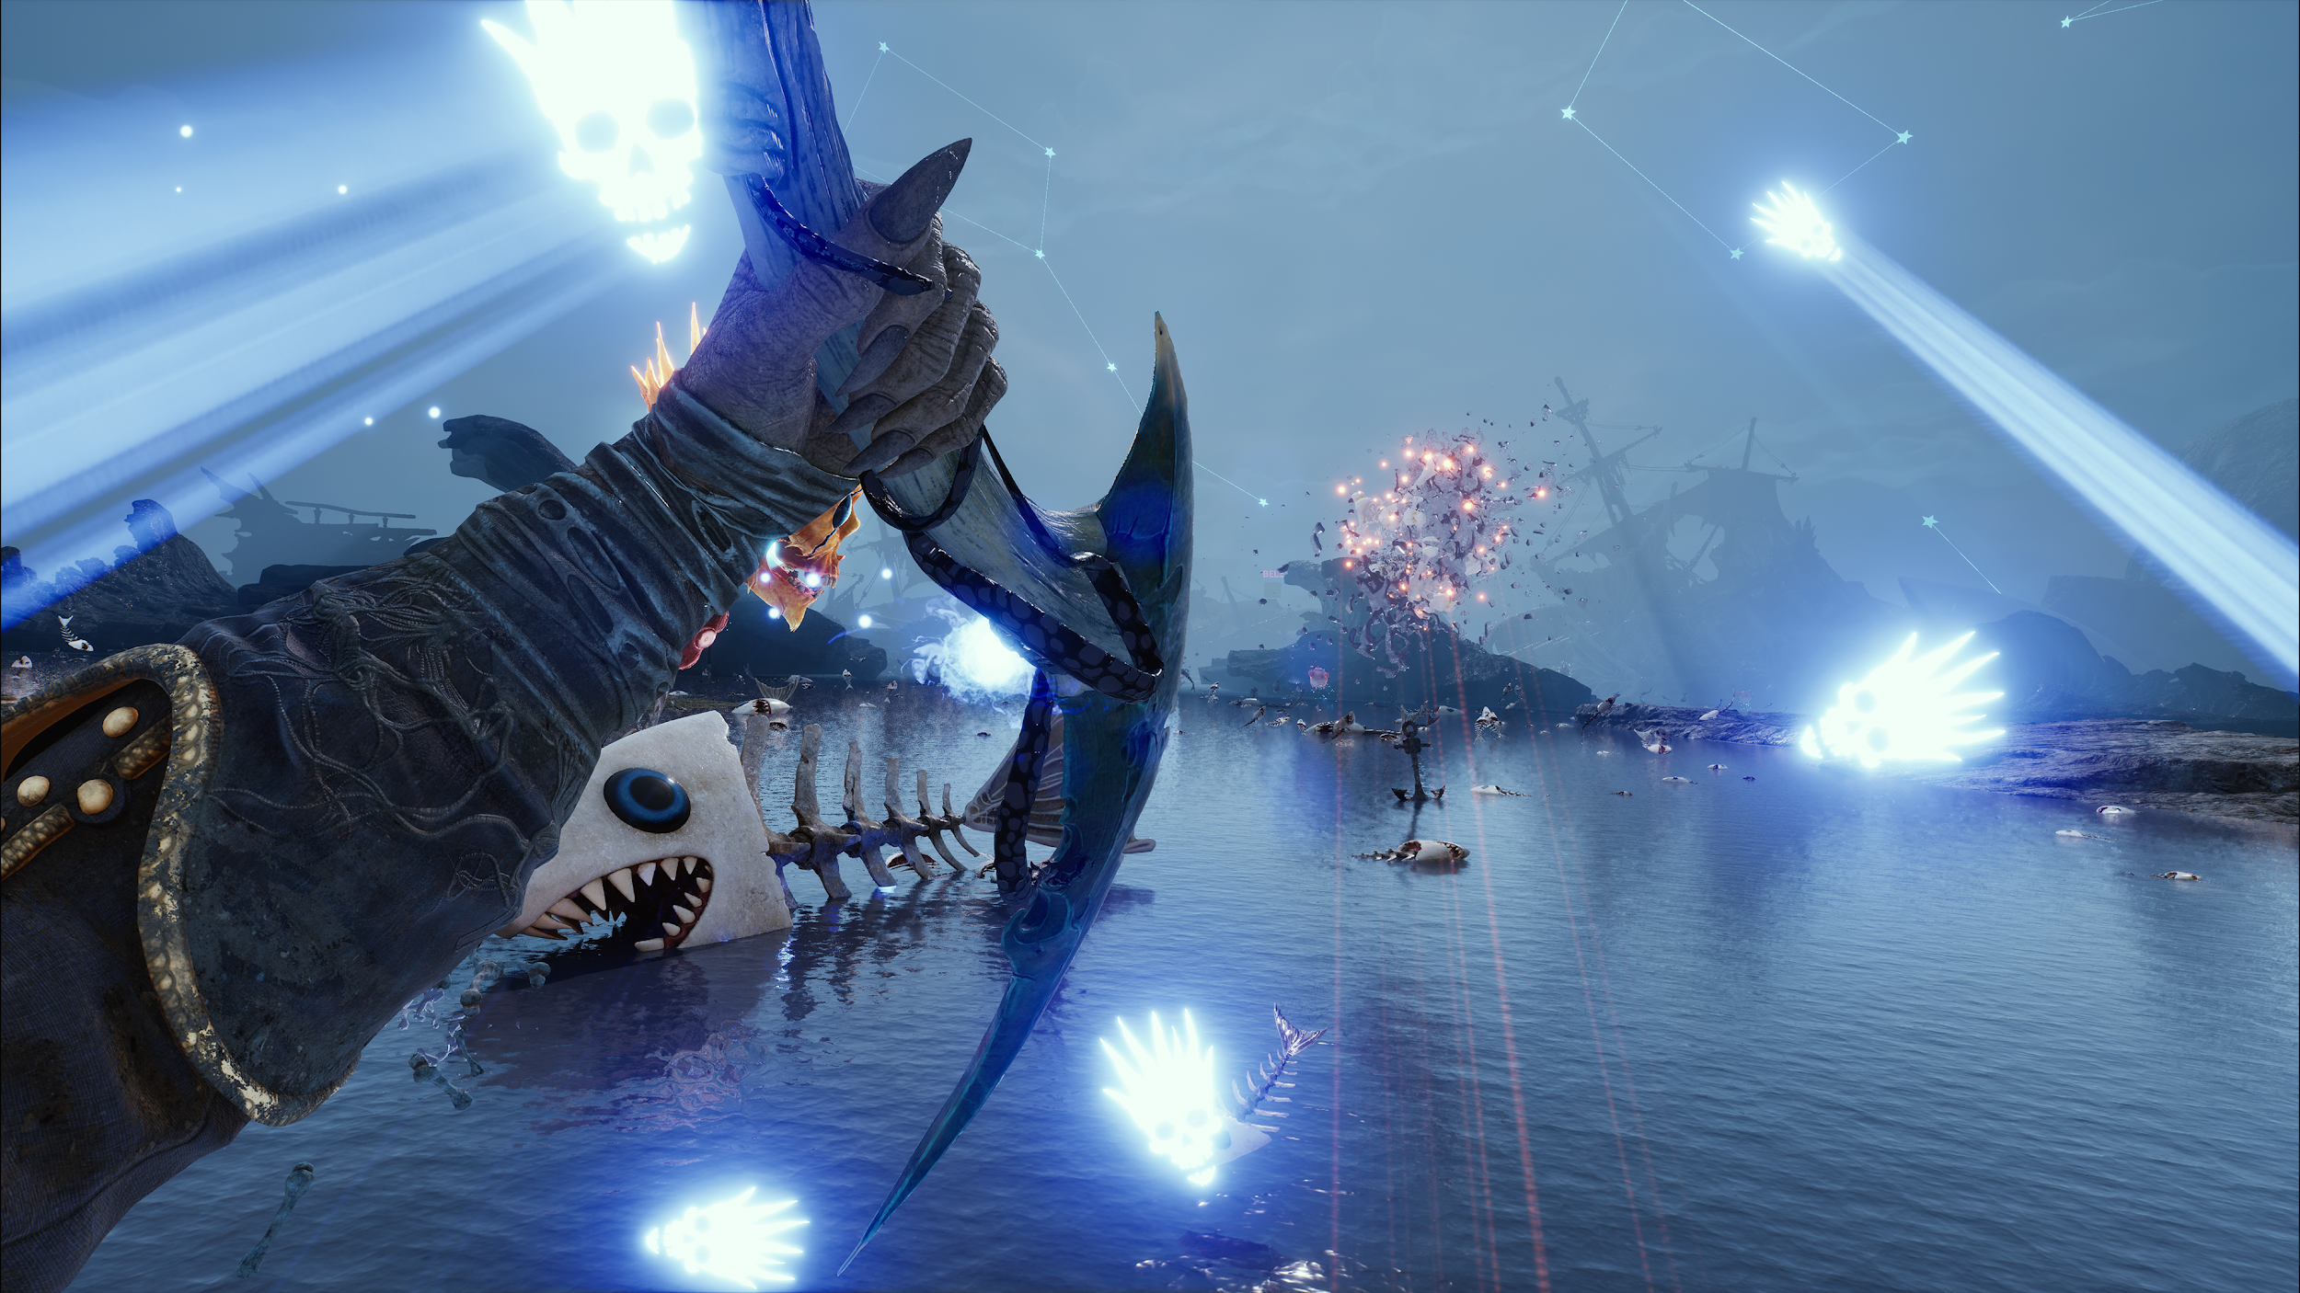

Buy DAVY x JONES on Steam Early Access: https://store.steampowered.com/app/2611170/DAVY_x_JONES/

Follow the game and the studio on Social Media:
- Twitter: https://x.com/DAVYxJONESgame
- Facebook: https://www.facebook.com/DAVYxJONES
- Instagram: https://www.instagram.com/parasight.studio/
- Discord: https://bit.ly/DAVYxJONES_Discord

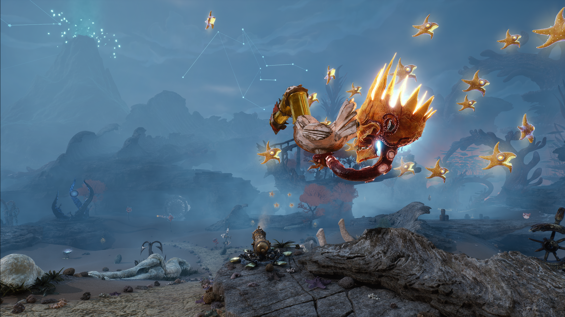
About PARASIGHT
PARASIGHT is a studio founded by industry veterans, dedicated to crafting immersive, living worlds where story fuels action. We create bold, character-driven games that merge gripping narratives with dynamic gameplay—inviting players to carve out their own legends and discover the unexpected.

MEDIA CONTACT:
Krzysztof Wojdyła
press@parasight.studio

