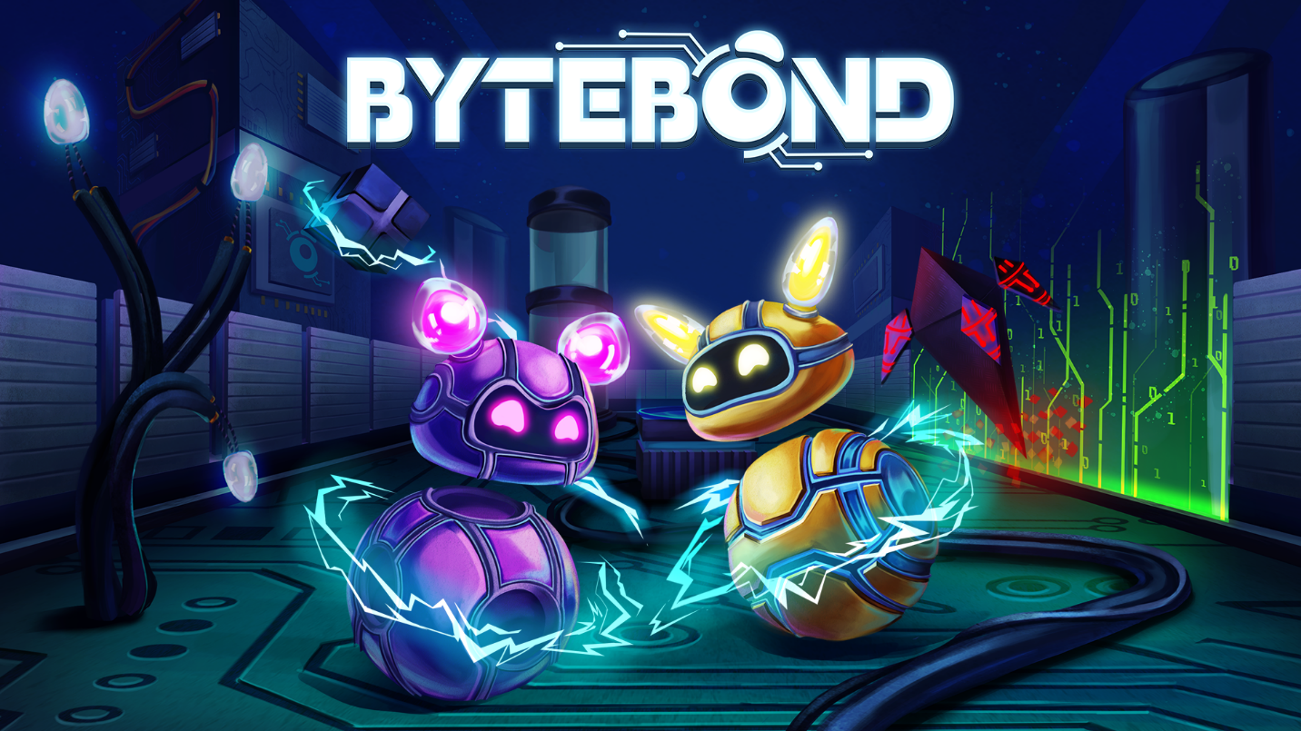

***BYTEBOND* LAUNCHES ON STEAM SEPTEMBER 18, 2025 – AN ELECTRYFYING CO-OP PUZZLE PLATFORMER THAT CHALLENGES YOU TO REGAIN CONTROL OVER AN INFECTED CPU**

**KATOWICE, Poland.** – **September 4, 2025** – Prepare to plug in and partner up – ***Bytebond*** is bringing its electrifying co-op adventure to **Steam on September 18, 2025**. Developed by DVD Unicorns with teamwork at its core, *Bytebond* invites players to connect and solve challenging puzzles during the journey inside the PC Computer. Whether teaming up online or sharing a couch, players step into the role of **Antivirus Special Forces droids** tasked with defending the system from a swarm of rogue virus bots.

***Bytebond* Release Date Trailer**: [YouTube](https://youtu.be/D33D-m_Yb2U?feature=shared)

**Press Kit**: [Download](https://1drv.ms/f/c/94e2ddaf00c8ad3a/EjqtyACv3eIggJRMKAAAAAABZJ1Z4rp6ul2D8KMp_z3Zdw?e=3DXV07)

***Bytebond***is a perfect blend of *Split Fiction*’s co-op interaction and storytelling and *Portal 2*’s inventive puzzles, offering an experience that will delight fans of teamwork and creative problem-solving. Explore various PC components like the CPU and the Cooling System, tackle new challenges, and discover the game’s innovative mechanics together.   
  
*Bytebond* is a great choice for families, couples, and friends looking to bond over an easy-going, collaborative gaming experience. The content is wholesome and ideal for group play, making it a perfect addition to family game nights or social gatherings.

**Key Features**

* ⚡ **Team up and power through** – Master energy management skills to charge machines, activate hidden systems, and unlock paths. Coordinate with your partner to solve puzzles that require perfect timing and cooperation.
* 🤖 **Battle virus bots** – Use teamwork and clever tactics to outmaneuver and delete them before they overrun the system.
* 🌐 **Explore a digital world** – Journey through glowing neon circuits, vast CPU corridors, and strange “data biomes” that feel alive. Each area hides secrets, shortcuts, and unique challenges.
* 🎮 **Play your way** – Swap effortlessly between online co-op, split-screen with friends, or solo play. No matter how you choose, the experience stays fast-paced, fun, and accessible.
* 🛡️ **Join the Antivirus Special Forces** – Control adorable yet powerful droids on a mission to save the system

*Bytebond* is coming to PC via [Steam](https://store.steampowered.com/app/1952690/Bytebond/) on September 18, 2025. For more information, visit the game’s [website](https://dvdunicorns.com/games/bytebond/), and follow along on [X,](https://x.com/ansharpublish) [BlueSky](https://bsky.app/profile/ansharpublishing.bsky.social), [Facebook](https://www.facebook.com/ansharpublishing), [TikTok](https://tiktok.com/@ansharpublishing) and [Steam](https://bit.ly/Anshar_Games) for the latest updates. Review Keys will be available starting September 4. We encourage media to contact us via [press@ansharpublishing.com](mailto:press@ansharpublishing.com) and secure your review keys.

**About Anshar Publishing**

Anshar Publishing is a video game publisher, focusing on indie games where the player's story is the sum of their choices. Founded in 2021, Anshar Publishing has released critically acclaimed products such as *Coridden*, *Gamedec - Definitive Edition*, *Zoria: Age of Shattering*, *Liberte*, and more. Discover more at [https://ansharpublishing.com](https://ansharpublishing.com/)

**About DVD Unicorns**

We are a group of passionate Polish developers who love to create games! We want our projects to provide entertainment for both the players and ourselves. In our games, we focus primarily on originality and unique mechanics. <https://dvdunicorns.com/>

**Media Contact**

Małgorzata Swat  
*Community Manager*  
[malgorzata.swat@ansharpublishing.com](mailto:malgorzata.swat@ansharpublishing.com)General Inquiries  
[press@ansharpublishing.com](mailto:press@ansharpublishing.com)<https://ansharpublishing.com/media/>