# 

# *Bygone Dreams* a high fantasy Action-Adventure set inside a surreal dream world gets a full release date announcement and a brand-new trailer

Olsztyn Poland June 6th, 2025,

## As well we are super excited that GrabTheGames partners with Cyberstep for the Asian region to bring this new game to Steam on June 20th 2025.

[Wishlist on Steam](https://store.steampowered.com/app/951620/Bygone_Dreams/?utm_source=Prout)

[Release Date Youtube Announcement Trailer](https://youtu.be/mC95W-wYZ3g?si=CHEuZDMndHUNcI09)

[Downloadable Trailer](https://www.dropbox.com/scl/fi/1n77vx5rfkn3g1y2i14hy/Bygone-Dreams-Full-Release-Date-Announcement-Trailer.mp4?rlkey=cz6h2t2bsgwy3jm3u8fbj2hwf&dl=0) (feel free to upload it on your media).

[Press Kit](https://www.dropbox.com/scl/fo/5dgf1xqp5i6gqcby7un3f/ANKU6Ap-eogxz6bgTgUtGnQ?rlkey=3akpo7tetb07bo7raaaq8uvyt&dl=0)

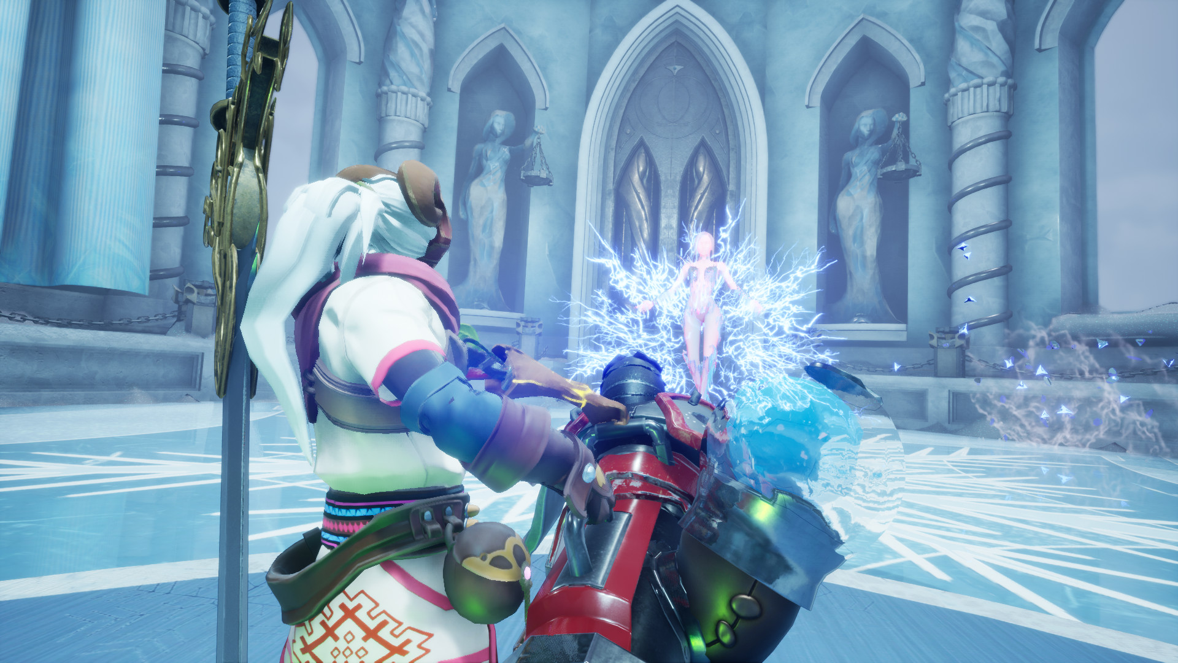

**About *Bygone Dreams*:**

*Bygone Dreams* is a high fantasy Action-Adventure set inside a surreal dream world. Face fantastical adversaries, solve puzzles, and fight your way through challenging bosses in your quest to save the world's matron deity and stop the nightmare consuming the dream.

* Winner of the Reboot Develop "Visual Excellence" award.
* Winner at the 2021 WN Dev Contest as chosen by Epic Games.

**Here are some key details you might find interesting:**

* Experience the epic story with over 2 hours of fully voiced cutscenes.
* 18 unique bosses
* 45+ enemies, each with distinct mechanics
* Full voice acting
* 52 unique soundtrack pieces, recorded by local Bosnian bands
* Crafting, looting, puzzles, and much more!

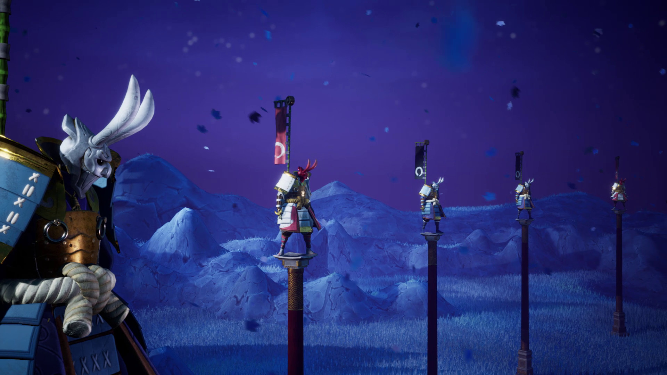

**About GrabTheGames:**

**GrabTheGames** is a publisher based in Olsztyn Poland with almost 100 titles published on multiple platforms, well know from titles like: *Ale & Tale Tavern, Gladiator Guild Manager, Outpath* or *Rungore*.

**About Prime Time:**

**Prime Time** is an independent video game developer dedicated to crafting innovative projects that merge diverse genres, artistic styles, and thematic concepts, with the goal of engaging a broad and varied audience. The studio’s most recent endeavor, *Bygone Dreams*, exemplifies this ambitious vision.

**About CyberStep:**

**CyberStep,** Inc. is a leading game developer and publisher from Japan which was founded in April 2000. From popular online action games such as *“Onigiri”* and “*GetAmped*”, to the world’s first online claw machine game “*Toreba*”, CyberStep brings over 20 years of experience and expertise in the game industry, providing players with the highest quality of entertainment. The company’s mission is to develop and realize never-before-seen ideas that can be enjoyed by people all around the world.