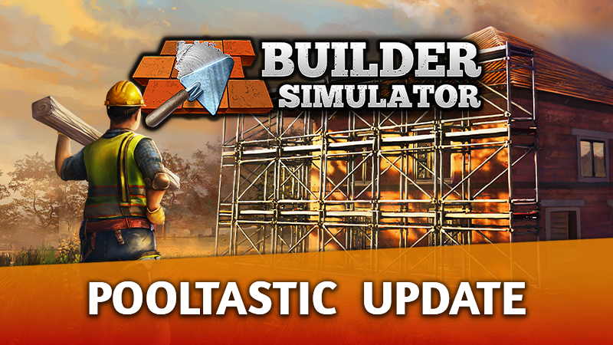
Title: Build your dream house, add a pool, and enjoy the swampy view thanks to the Pooltastic Update!

[trailer]

Standfirst:

Since the release of Builder Simulator (June 9th, 2022), the developers have been putting as much effort as possible into making the game even better. After gathering enough feedback from the community, we're happy to announce the Pooltastic Update!

For immediate publication: 28/07/2022 – Cracow, Poland

Thanks to the Pooltastic Update, players will have the unique opportunity to build their dream house surrounded by SWAMP! The developers have also prepared something for anyone impatiently waiting to get wet. From now on, you'll be able to admire your creations even more, as the update will introduce a much-anticipated addition – pools! But that's not all. Prepare yourself for true madness, because the update will introduce approximately 150 new pieces of furniture, all at your disposal. And the icing on the cake – a 20% discount coinciding with the release of the Pooltastic Update.

[screenshots]

Pooltastic Update comes with:
- A 20% discount on Builder Simulator.
- The addition of pools.
- A brand-new swamp level.
- Around 150 new pieces of furniture.
- A construction stage progress tracker.
- The ability to change already-placed doors and windows.
- A selection of windowsills and the possibility of replacing them at any time.
- And much, much more!

If you still didn't manage to grab a copy, now is the time. And last but not least, don't forget to follow the developers' social media channels to stay up to date on any news.

About Frozen Way:
We are a development studio and publisher from Cracow. You may know us from co-creating House Flipper and creating and releasing House Flipper VR and the House Flipper - Pets DLC on Steam. We are a group of friendly people with a passion for video games. Gamedev is our lifestyle and philosophy, so there's nothing better than seeing our creations bring joy to the community. In the end, we're all nerds, aren't we?

About Live Motion Games:
Live Motion Games S.A. is part of the video game industry. Currently, we're working on several games at various stages of development. Our strategy is to create and sell titles worldwide using a digital model through the Steam platform. Since June 2021, we've been listed on the New Connect market.

