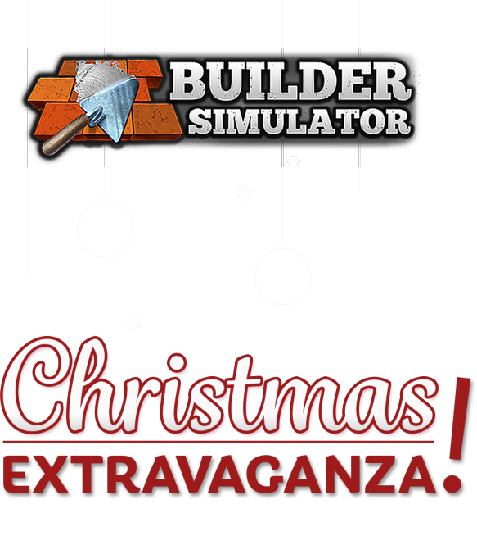

The Christmas Extravaganza in its purest form comes to Builder Simulator!

Watch the Builder Simulator Christmas Extravaganza trailer HERE.

December 15th, Cracow, Poland.

Christmas has come early this year, Builders! Since we only have your best interests in mind in Builder Simulator, we've prepared a special gift for you. We're very happy to announce the Christmas Extravaganza update!

Get the game from Steam (https://store.steampowered.com/app/1120320/Builder_Simulator/) 30% off until December 22nd.

About Builder Simulator

Builder Simulator is a simulation game that will be exciting for anyone who enjoys building from scratch. Prepare your plan, buy the required materials, and build the perfect residence brick by brick. Will it be a simple task? At first, yes! After all, you're just a rookie in this serious building industry. A specially-made tutorial will guide you step by step through the twists and turns of construction work. Simply gain more experience, and more demanding work will follow.

The Christmas Extravaganza Update comes with the following:

- A special 30% discount on Builder Simulator,
- A new seasonal map filled with a Christmas atmosphere,
- Special Christmas decorations such as lights of every color, ornaments, and – of course – reindeer,
- A new functionality – balconies! Now you have even more space to illuminate your home, so it can be lit up like a Christmas tree!
- New engaging contracts that will keep you entertained this Christmas!

If you are still dreaming about building your own house, don't wait for a second longer! Remember that the proof is in the pudding, so immerse yourself in the world of Builder Simulator. We guarantee that the surroundings of your house will be even more awesome when everything is covered in snow! So – eat, drink and be merry, Builders!

The press kit for the game is available at the following link: https://pr-outreach.com/en/game/builder-simulator,40.

For any questions about the game please get in touch with Agnieszka Szóstak at agnieszka.szostak@pr-outreach.com or call +48 881 951 601.
_________________________________________________________________________

About Frozen Way:
We are a development studio and publisher from Cracow. You may know us from co-creating House Flipper and creating and releasing House Flipper VR and the House Flipper - Pets DLC on Steam. We are a group of friendly people with a passion for video games. Gamedev is our lifestyle and philosophy, so there's nothing better than seeing our creations bring joy to the community. In the end, we're all nerds, aren't we? https://frozenwaygames.com/
_____________________________________________________________________________________________________

About Live Motion Games:
Live Motion Games S.A. is part of the video games industry. Currently, we're working on several games at various stages of development. Our strategy is to create and sell titles worldwide using a digital model through the Steam platform. Since June 2021, we've been listed on the New Connect market. https://livemotiongames.com/

