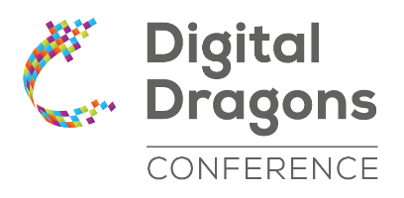

Digital Dragons is currently one of the largest international events for the digital entertainment industry in Central and Eastern Europe. The main goal is to create a Business to Business (B2B) cooperation platform within the games sector in Europe. This year’s edition will be held at the ICE Kraków Congress Centre on 15 and 16 May 2023
Digital Dragons Conference includes:
- Digital Dragons Awards - prestigious gaming industry awards
- Indie Showcase - curated selection of the best, most interesting titles on the independent scene – games close to release, already released and titles still ways off from launch, but already possessing the necessary “it” factor. We will invite 50 chosen developers to show playable versions of their games at our Digital Dragons showfloor at Kraków’s ICE Congress Centre – 20 of which will compete for our main prizes. But all of them will vie for attention of investors, publishers, as well as other devs and all our other guests at Digital Dragons
- Digital Dragons Arena - marketplace: space for young game development studios seeking business partners that doubles as an opportunity for representatives of VC funds, business angels, publishers, and media to meet attractive teams with large potential
- Lectures and panel discussions - conference programme features six thematic tracks this year covering the widest possible spectrum of topics in the industry: art in games, games design, business and marketing, mobile, programming and technology, production and leadership, blockchain

We love gamedev since 2012
Over the past 10 years, 9 320 publishers, producers and developers visited the Digital Dragons Conference. It began as a niche, intimate event – now it’s a brand recognized all over the world. This year we are celebrating the 10th anniversary of this event, continuously organized by the Kraków Technology Park since 2012.
The Digital Dragons Conference is one of the elements in the complex offer that the Kraków Technology Park has designed for the gamedev sector. It comes together with incubation and acceleration programmes for young studios, and training programmes, notably the Digital Dragons Academy earmarked for university students.

Contact
Krzysztof Szeremeta
promotion manager
kszeremeta@kpt.krakow.pl
mob. +48 698 820 871
www.kpt.krakow.pl
www.digitaldragons.pl

